
International Psychologist
http://icpweb.org

Vol. 49, No. 4 International Council of Psychologists May 2009

President: M.Consuelo Barreda-Hanson, PhD
NSW, Australia
cbarreda-hanson@iom.int

Past President: Chok Hiew, PhD.
NB, Canada
hiew@unb.ca

President-Elect: Ann M. O’Roark, PhD.
annoroark@bellsouth.net

Secretary-General and Treasurer:

Secretary: Edit Nagy-Tanaka, PhD.
Tsukuba Science City, Japan
icp.secretary@yahoo.com

BOARD MEMBERS AT LARGE
Term Expires in 2009
Beth Hedva, PhD Calgary, Canada
beth@hedva.com

Varda Muhlbuer, PhD Tel Aviv, Isreal
vardam@netvision.net.il

Florence Denmark, PhD USA
fdenmark@pace.edu

Imelad Villare, PhD Philippines
imeldavillar@yahoo.com

Term Expires 2010
Ana Guil, Seville, PhD., Spain

Ani Kaiayjian EdD.,, New Jersey, USA
kalayjiana@aol.com

Julia Rose, Birmingham, UK
Rosejulia6@aol.com

Term Expires 2011
Amos A. Alao, PhD.., Botswana
ALAOAA@mopipi.ub.bw

Michael J. Stevens, PhD ., USA
mjsteven@ilstu.edu

Fernando Arias Galicia, PhD., Mexico
ariasgalicia@prodigy.net.mx


Painting by Mexican artist Diego Rivera who has travelled
to many parts of the world and displayed works of art.
He won many international acclaim for his paintings that were
exhibited the world over. Apart from being a painter and a
Muralist he was also an active communist until he died in 1957.

Inside this Issue



President’s Message…………………………………………………………………………..4

ICP 67th Conference..........................................................................................7

Conference Registration....................................................................................8

Letter from the Government of Mexico City.....................................................13

Preliminary Conference Synopsis....................................................................14

Conference Paper Poster Presentations...........................................................19

Workshop: “Intra and Cross Cultural Non-verbal Communication”.................22

Bylaws and Board Rules: Section II of ICP......................................................24

2009 Spring Election Ballot............................................................................52

Candidate Information....................................................................................54

Introducing the New Editors...........................................................................65

ICP Membership Application – 2009…………………………………………………….66

Managing IP Editor: Sonia Dhaliwal, MA dhal9660@pacificu.edu
Co-Editor: Elizabeth Stotler-Turner, MS
Principle Research Coordinator-Editor: Merima Isakovic-Cocker, PhD., findme@merimaisakovic.info



Contact Information

2009 Convention Arrangements: ICP Past President Dr. Elisa Margaona, maresa@prodigy.net.mx

- World Area Chair Coordinator: Dr. Sandra E.S. Neil: office@satiraustralia.com

- International Association Liaison Chair: Dr. Joy Rice: jkrice@wisc.edu

- Membership Chair: Dr. Julia Rose: Julia.Rose@hmps.gsi.gov.uk

- UN NGO Chair: Dr. Florence Denmark: fdenmark@pace.edu

- International Psychologist, Vol. 49, 2:
- Managing editors:
- Sonia Dhaliwal dhal9660@pacificu.edu
- Elizabeth Stotler-Turner stot8922@pacificu.edu

- Principle Research Coordinator: Dr. Merima Isakovic-Crocker findme@merimaisakovic.info

- Communicationa and Publications Chair: Dr. Richard Velayo rvelayo@Pace.edu

- Convention Proceding Editor: Dr. Roswith Roth roswith.roth@kfunigraz.ac.at

- Secretary-General: Vacant. Search Committee to make Recommendation Spring 2009 annoroark@bellsouth.net

- 2009 Payments for Dues and Membership Applications: cstratton@Wiley.com

- All 2010 Payments to ICP Treasurer: June 1, 2009 Interim Treas: Dr. Gerald L. Gamache: geraldgamache@bellsouth.net

PRESIDENT M. CONSUELO BARREDA-HANSON
ICP 67TH CONVENTION IN MEXICO CITY JULY 4-7, 2009
A TRIBUTE TO MEMBERS COMMITMENT AND EFFECTIVE HEALTH THREAT PROBLEM SOLVING BY GLOBAL HEALTH MANAGEMENT ORGANIZATIONS AND GOVERNMENTS

Dear Colleagues and Friends,

As 2008 ended with world crisis, so has the start of 2009 – the wars, the economy and now the swine flu. But this is not new to ICP. We have gone through many trials and always been able to overcome them. A couple of examples are the war we went through in Israel and the blackouts in Canada. In each occasion we managed to carry on very successful conventions. This is a tribute to our commitment to ICP and our problem solving. I know we shall again prove able to carry on because we can.

I have been receiving advice from WHO, UN, Red Cross and my medical advisors in Australia, with whom I am in regular contact. I continue to receive very reassuring news. It seems that panic is a greater epidemic than the flu as much of the news we hear through the media has been unfounded, but then, this is not rare. For example, in the 1976 swine flu scare, the US Health, Education and Welfare Department stated that “The projections are that the virus will kill one million Americans” but only one died from the virus and another 33 from the vaccinations that the US Government had ordered in its “Do Something” panic. In 1995 the Newsweek cover had CNN calling the Ebola flu the “Apocalypse bug!” but in actuality it only killed 800 people and all in Africa. In 1997 there was also a great scare with the bird flu that caused headlines such as “Race to prevent world epidemic” but killed only six. In 2203 the BBC warned that SARS would have “a similar impact to the 1918 flu epidemic that killed 50 million” but less than 1000 died and most in poorer Asian countries, with even poorer health care. More recently, in 2005, when the bird flu hit us, the US National Center for Disaster warned us that “We could have a billion people dying worldwide” but in the end it killed just 257 people. These scary warnings and stories may, I think, assist in prevention, as has been seen in the prompt and successful immediate intervention and prevention plans activated by Mexico (that now has good drugs available and excellent medical services as well as many well equipped hospitals in the city) and other countries around the world. Recent data indicate that 26 persons have died in Mexico (though only 8, after more careful checking, at the time of the reports I received had been officially confirmed to be due to the swine flu) out of 1,500 cases in an overpopulated country of 103. Colds and/or the flu as well as other diseases kill thousands in Mexico alone. This is equally true in all other countries. In Australia, for example, car accidents alone kill hundreds a month. According to the World Health Organization the regular influenza kills between 250,000 and 500,000 people every year. In Australian alone, the normal flu or pneumonia kills about 3000 every year and in Americans it kills about 36,000.

Through history we have developed knowledge and resources to combat epidemics. We now have better communication and can now isolate outbreaks and vaccinate immediately the people that are more at risk. We also have drugs such as Relenza and Tamiflu that have offered good protection against the latest flu varieties and we also have powerful antibiotics and anti-bacterial drugs for the secondary bacterial infections. And, we, on the whole, are much healthier with a better awareness of how to be healthy and maintain health, thus have higher tolerance and greater immunity.

The Mexican Government is reporting that the number of the sick continues to fall and that no cases had been found of people over 50 or within families. This indicates that the flu is not so contagions as assumed. Similar reports are coming from other countries, indicating that the sick are recovering quickly, as they do from any other flu when treated properly. The US Center for Disease Control and Prevention recently noted “So far, this is not looking like very, very severe influenza”. The two cases reported in Australia and interviewed by our media, said their symptoms were more like a mild cold. So, as Dr. Elisa Margoana put it in one of her emails “We are fine and we know we will be better.”

Based on the above facts, the Executive Committee sees no reason to cancel our Mexican Conference and we encourage you to consider your situation and decide, not out of fear but out of the facts provided. We have many members indicating they will be coming and so far there have been no cancellations. We also have confirmation of a group of 13 students from the U.S. individuals from Nigeria and Spain who have not cancelled as well as Mexicans and people from neighbouring countries. In case you have already registered and wish to withdraw. ICP will honor your withdrawal and return your registration fee. In Mexico, Dr. Elisa Margoana is in consultation with the hotel and informs us that the hotel was willing to honor the deposit for next year, but had no money to reimburse. If you are also cancelling your hotel reservation you may need to check directly with the hotel.

I want to advise of a couple of changes. Dr. Denis Trent had to resign from the position of World Area Chair Coordinator. Dr. Sandra E.S. Neil has now accepted the role. Dr. Annie Crooks also had to resign from her position as IP Editor. This role has been accepted by Sonia Dhaliwal, MA a student of Pacific University, Forest Grove, Oregon. We welcome them both to these important roles and thank them for taking over.

I am now starting to put together the Board Book for Mexico. In order to complete this, I will be most thankful if all members who had a role and/or task could please send me their reports as soon as possible. Other reports that were requested from our meetings in Russia include the submission of role description and suggestions and/or additions to the AP&P for Board consideration.

Again, I thank all those who have continued to provide the Executive with your support, advice and input, particularly during difficult times. I welcome you all to our Mexico Conference which will prove to be a great success.

M. Consuelo Barreda-Hanson, Ph.D
2008-2009 ICP President

ICP WORLD REUNITED

MEXICO WELCOMES YOU

ICP 67thCONFERENCE
July 3rd to July 8th, 2009
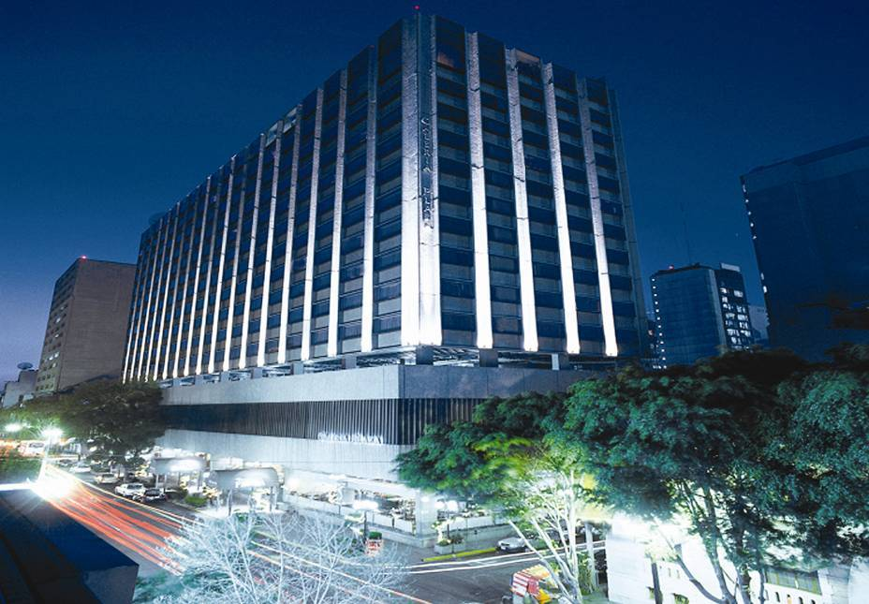

Hotel Galeria Plaza. Mexico City
Hamburgo 195
Col. Juárez
México, D.F. CP 06600
Website: www.brisas.com.mx

Hotel Room Reservation:
Please request the special rate for International Council of Psychology when making your reservation.
By Phone: (52) (55) 5230-1717 fax: (52) (55) 5207-5867
By email: galeria.plaza@brisas.com.mx
OR: evelynmartinez@lacasadelviaje.com

The hotel where the meetings will be held is Hotel Galería Plaza, (5*), one block from Reforma Avenue, Mexico City. The exceptional price for ICP members is $124.00- USC y (taxes included, rate 2009), for double or single room, with Internet access, satellite TV. In the “Brisas Business Club Floor” rooms are $170.-USCy (with taxes), including telephone calls, continental breakfasts, bar and Hors d’oeuvres from 12 to 22 hours and an Executive Lounge. The hotel has two restaurants and a lobby bar. There is a beautiful roof garden with a pool. Check-in time: 14:00 Hrs. Check-out time: 13:00 Hrs.
Airport Transfer:
If you let us know in time, we will try to meet you at the international gate of the Benito Juarez Airport. If not, be sure to take the registered taxi service, inside the airport.


Figure 1 Galeria Plaza Hotel

ICP 67thCONFERENCE EXPECTS FRIENDS FROM ALL OVER THE WORLD


THEME: “SCIENTIFIC PSYCHOLOGY:
NEW DEVELOPMENTS INTERNATIONALLY”

What is Happening Within Countries and Trans-Nationally to Encourage Evidence Based Practice, Quality Caring for Individual Well-being, & Advancement of Psychology?

President-Elect and Program Chair: Dr. Ann M. O’Roark

ICP Mexico City Registration Fees:

Member Category | Registration Fees Regular: Up to April 10, 2009  USCy | Registration Fees  From April 11-June 10, 2009  USCy | Registration Fees  From June 11-  On site  UsCy
Members  Countries: Category A  Category B  Category C | 300.00  200.00  150.00 | 325.00  225.00  175.00 | 350.00  250.00  200.00
*Students:  Member  Non-Member | 75.00  100.00 | 75.00  100.00 | 75.00  100.00
Non Members  Professional | 300.00 | 325.00 | 350.00
Person-Accompanying | 100.00 | 100.00 | 100.00

- Country of residence determines registration fees above:
Category A Countries:
Australia, Austria, Bahrain, Belgium, Brunei, Canada, Denmark, Finland, France, Germany, Great Britain, Greece, Hong Kong, Iceland, Ireland, Israel, Italy, Japan, Kuwait, Luxembourg, Netherlands, New Zealand, Norway, Portugal, Qatar, Saudi Arabia, Singapore, Spain, Sweden, Switzerland, Taiwan, United Arab Emirates, USA.

Category B Countries:
Antigua & Bermuda, Argentina, Bahamas, Barbados, Brazil, China, Croatia, Cyprus, Czech Republic, Iran, Korea, Malaysia, Malta, Mexico, Oman, Poland, Seychelles, Slovakia, Slovenia, South Africa, Suriname, Turkey, Venezuela, Yemen.

Category C Countries: All other countries.
- A certificate of Student status issued by the applicant’s university department is required
- All prices in US Currency.
Registration includes:
- Full access to All Congress Scientific Sessions
- Congress Bag & Badge
- Book of program/Abstracts
- Admittance to Opening Ceremony & Welcome Reception

Registration Fee for Accompanying Persons Includes:
- Admittance to the Opening Ceremony & Welcome Reception
- Special ICP Prices for Organized tours & dinners
- Full access to All Congress Scientific Sessions

REGISTRATION AND other events you wish to register FOR:

WRITE DOWN AMOUNT FOR: |  |  |  | US CY
Registration payment | ICP Membership Status
Accompanying Person(s)
They are welcome to attend
ICP Program Sessions
EVENT: | Sunday  July 5, 2009 | Monday  July 6, 2009 | Tuesday,  July 7, 2009
LUNCHEONS | 25.00 | 25.00 | 25.00
CLOSING BANQUET |  |  | 40.00

CEU WORKSHOPS & FEES
to be announced in 2009
***Add above for the
Total Payment

INCLUDE with each SUBMISSION:

Your name:

Institution:

Abstract: Obtain format from web page

Full Name of Chair and/or Organizer of Session:

SUBMIT Proposals to:
Work & Home Address, Email, Telephone
Dr. Ann M. O’Roark
400 Misty Morning Lane
St. Augustine, Florida, 32080, U.S.A.
EMAIL: annoroark@bellsouth.net
Telephone: USA: (904) 461 3382
Include Contact information & ICP status of PARTICIPANTS in the session.
ICP Membership Status Office /Committee.

ALL TOURS AND SIGHT SEEING ARE BY INDIVIDUAL ARRANGEMENT
FOR THOSE WHO WISH ASSISTANCE PLEASE CONTACT:

POST-CONFERENCE ONE DAY TOURS: July 9th, 2009.
- Xochimilco (Floating Gardens).
- Teotihuacan–Pyramids.
- Archaeological Museum. City Tour. City of Puebla, (XVII Century)
SUGGESTED TRAVEL AGENCY FOR PERSONAL ATTENTION: La Casa del Viaje, S.A. de C.V. Hamburgo # 42-1, México, D.F. C.P. 06600.
Representative: Evelyn Martinez.

Phone: (52)(55)5242-9405. FAX: (52) (55)5242-9401
email: evelynmartinez@lacasadelviaje.com
Web Page: http://www.lacasadelviaje.com

Registration Form
Complete all of the following information
SUBMIT TO ICP2009 CONVENTION REGISTRAR

Ms. Nancy Quatrano
4625 Cedar Ford Blvd.
Hastings, FL 32145
Phone: 386-546-5164
Fax : 386-329-6161
Email: qss@nlquatrano.com

Dr. Prof. Ms Mr. Mrs. Others
Last Name: ___________________________
Given Names: _____________________________
Department/Organization:_________________________________________
Preferred address for correspondence:
Office Address Home Address
Please give your country code for phone + fax.
Address: Street:
City:
State: |  |  |  |  |  |  |  |  | Zip:
Country:
Office Phone/Fax: |  |  |  |  |  |  | Home Phone:
Email:
Preferred Name on Badge:
Special dietary/disability requirements (Please specify)

Registration is payable via Credit Card (Master Card or Visa) or Money Order, only. Money Orders should be made payable to the ICP.

MC ____ VISA ____ CARD NUMBER: _____________________________________
Exp. Date: _____/_____ Signature: _______________________________________
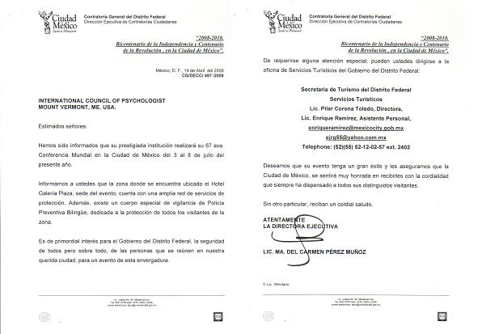
INTERNATIONAL COUNCIL OF PSYCHOLOGISTS
67TH ANNUAL CONVENTION

MEXICO CITY JULY 4-7, 2009

Hotel Galeria Plaza. Mexico City


Preliminary Program Synopsis


CONVENTION ART EXHIBIT
Selected Mexico Painting Reproductions
Joan Fimbel Digiovanni, PhD. ICP MEMBER

“SCIENTIFIC PSYCHOLOGY:
NEW DEVELOPMENTS INTERNATIONALLY”

What is Happening Within Countries and Trans-Nationally to Encourage Evidence Based Practice, Quality Caring for Individual Well-being, & Advancement of Psychology?

Program Chair: Ann M. O’Roark (USA) Committee: Noach Milgram (Israel); Rosewith Roth (Austria); Anna Laura Comunian (Italy); Natividad Dayan (Philippines); Machiko Fukuhara (Japan)

Local Arrangements Coordinator: Elisa Margaona (Mexico)

CONVENTION NEWS: GALERIA HOTEL OFFERS DISCOUNT RATE TO ICP REGISTRANTS

Local Arrangements Chair Elisa Margaona reports that in the wake of the flu health concern: I asked for the discount. They gave it to us, even if the rate was already one of the lowest in the city. .. we just made a research in 5* hotels, in the neighborhood of [the Galeria] …(better than downtown), with a pool, safe measures like constant air conditioning cleaning, etc. and we have made a comparison table for you. Now we are aware of one of the best hotel rates!!! We are ready to welcome you with even more suggestions.

FIVE STARS HOTELS
 |  | RATE (USCy) | TAX | TOTAL RATE | INCLUDED
Galería Plaza
 | Single or double room (luxury) | $92.00 | $16.00 | $108.00 | Local phone calls. Business Center.
 | Brisas Business Club | $127.00 | $22.00 | $149.00 | Continental breakfast, coffee, tea, cold drinks. Bar (local) from 7p.m.
Sheraton Maria Isabel
 | Single or double room | $155.00 | $26.35 | $181.35
Marquis Reforma
 | Single or double room | $165.00 | $28.05 | $193.05 | (Buffet breakfast included.)
Four Seasons
 | Single or double room | $255.00 | $43.35 | $298.35 | (American breakfast included.)
Fiesta Americana Reforma
 | Single or double room | $115.00 | $19.55 |  | (Buffet breakfast included.)
 | Tips incl. In bill |  | $3.60 | $137.15

Please View Schedule below. Thank You.

Event | Date | Time
Outgoing Board Meetings with Consuelo Barreda-Hanson | July 3, 2009 | TBA
- Workshop. Jorge Cappon Gotlib, PhD., Mexico City [psychotherapy]  - Workshop. Mercedes McCormick, PhD. New York City [technology] | July 4, 2009
Opening Ceremonies & Welcome Reception | July 4, 2009 | 1800hrs-2100hrs
Start | July 5, 2009 | 0900-1800hrs
Symposia and Paper presentations | July 5, 2009 | 0900-1030hrs
Inabsentia Posters. Art Exhibit | July 5, 2009 | 1030-1100hrs
Invited Plenary, Marcello Urra, PHD SIP VP, South America | July 5, 2009 | 1100-1200hrs
- Lunch. United Nations Representatives & International Liaisons.  - Florence Denmark,PhD, New York, & Joy Rice, PhD, Wisconsin, Hosts | July 5, 2009 | 1200-1400hrs
Symposia and Papers | July 5, 2009 | 1400-1530hrs
Workshop. M.C. Barreda-Hanson, Ph.D, Australia. | July 5, 2009 | 1400-1700
Afternoon Break INABSENTIA Graduate Student POSTERS. ART EXHIBIT | July 5, 2009 | 1530-1600 hrs. .
- Conversation  - Round Table Sessions | July 5, 2009 | 1600-1700 hrs.
Invited Pleanary. Rice, Joy PhD. Madison Wisconsin USA | July 5, 2009 | 1700-1800 hrs.
Start | July 6, 2009 | 0900-1800 hrs
- Symposia  - Paper Sessions | July 6, 2009 | 0900-1030hrs
INABSENTIA Graduate Student POSTERS. ART EXHIBIT | July 6, 2009 | 1030-1101hrs
Invited Plenary. Rolando Diaz- Loving, PhD, Mexico | July 6, 2009 | 1100-1200 hrs
Lunch. Research Interest Groups, CE & IP [Merima Isakovic-Crocker, PhD, New Zealand, & Mercedes McCormick, NYC USA, Hosts] | July, 6, 2009 | 1200-1400 hrs
- Symposia  - Paper Sessions | July, 6, 2009 | 1400-1530 hrs.
- Afternoon Break INABSENTIA POSTERS.  - ART EXHIBIT. | July 6, 2009 | 1530-1600 hrs.
- Conversation  - Round Table Sessions | July 6, 2009 | 1600-1700 hrs.
Invited Pleanary. Gerald L Gamache, PhD, St. Augustine, FL USA | July 6, 2009 | 1700-1800 hrs.
Start Time | July 7, 2009 | 0900-1800hrs
Award Presentations, Symposia and Paper Sessions | July 7, 2009 | 0900-1030hrs
Morning Break. INABSENTIA POSTERS. ART EXHIBIT | July 7, 2009 | 1030-1101
Invited Plenary. Sandra E.S. Neil, PhD., Melbourne, Australia | July 7, 2009 | 1100-1200 hrs
Lunch. World Area Chairs & Membership.  Sandra E.S. Neil, PhD, Australia, and Julia Rose, England, Hosts | July 7, 2009 | 1200-1400 hrs.
Award Presentations, Symposia and Paper Sessions | July 7, 2009 | 1400-1530 hrs.
Afternoon Break INABSENTIA POSTERS. ART EXHIBIT. | July 7, 2009 | 1530-1600 hrs
Closing Plenary: to be announced | July 7, 2009 | 1600-1700 hrs.
- ICP MEMBERSHIP MEETING  - Presidential Appreciations  - Remembrance for Matti Gershenfeld: President, CE Chair, Secretary General | July 7, 2009 | 1700-1800 hrs.
- Annual BANQUET  - Incoming Board Meeting. A.M. O’Roark, presiding | July 7, 2009  July 8, 2009 | 1900-2100 hrs.  0900-1800hrs

July 10th. Friday. Garden City Cuernavaca University of Morelos.
17:00 hrs. Inauguration of Post-Congress Symposium. [NO FEE]
July 11th. Symposium. “Quality of Life” HOST: BOARD DIRECTOR FERNANDO ARIAS-GALACIA

LOOK FOR THE 67TH ANNUAL PROGRAM DETAILS IN THE NEXT TWO WEEKS

http://rvelayo.com/icpweb/

A link to conference information is on rvelayo.com/icpweb/ first page

2009 Paper Poster Presentations



ICP President, Consuela Barreda-Hanson, NSW, Australia
President-Elect, Ann M. O'Roark

Co-Chairs
Anna Laura Comunian, PhD, Padua, Italy, Coordinator
Natividad Dayan, PhD, Manila, the Philippines
Ani Kalayijan, PhD, New Jersey, USA

GRADUATE STUDENTS, EARLY CAREER PSYCHOLOGISTS, and ICP MEMBERS
In Absentia Graduate Student Posters: Topics in International Psychology
______________________________________________________________________

This conference will feature an exhibit of poster papers that will be continuous throughout the conference. Posters will be displayed in meeting rooms and near the registration desk.

A senior member of ICP will collect and send the letter of feedback about outstanding features of each poster and the needed areas for improvement. This is a continuation of In-Absentia poster sessions initiated to provide mentoring to undergraduate students, graduate students, and early-career psychologists.

ICP is a person-to-person association. As a mentor/incubator association, ICP welcomes a diversity of psychology students and encourages their interest and/or exploration in issues pertinent to International Psychology.

- Agrillo C., Agrillo D. (Correspondence to C. Agrillo, Department of General Psychology, Via Venezia 8, 35131 Padova (Italy) Email: cristian.agrillo@unipd.it. Depression among cultures: Diagnostic Issues
- Armenti A. (Psychologist, Interaction & Cultural Lab., Department of General Psychology, University of Padova), Mediated Communication Technologies (MCTs) for remote family members’ interaction
- Bordon E., (Phd student in Sociology and Social research- University of Verona) Nobile F., (Graduate in Psychology- University of Padova) The influence of imitation on metastereotypes. Experimental study in Holland and Italy: two countries in comparison.
- Brown C. (Graduate fellow, Department of Psychology, Saint Luis University), Ruebelt S.G., Peri A., Pre-Migration Preparation Predicts United States Acculturation among University from Five Continents.
- Buonaiuto P. (Psychologist, First University of Rome), Biasi V. (Psychologist, Third University of Rome), Barella F., D’Aloise D., Sciuto J. (Graduate Students, First University of Rome), “The color family drawing” in different family types and cultures
- Ferro L. (Phd-Psychologist, Department of General Psychology, University of Padova c/o Prof. Tessarolo), L’intrattenimento attraverso la malattia in una cornice di fiction televisiva. Il caso del Dott. House
- Gianotti M.A., (Dipartimento di scienze dell’educazione- facoltà di scienze della formazione- Università di Roma 3) Machado D.Z. (Psychology Drug Addiction Association of Paranà, Curitiba, Paranà, Brazil) Bartoszeck A.B. (Neuroscience and Education Lab. Physiology Department, The Federal University of Paranà), Drawings of the body inside Italy and Brazil: a comparative study
- Gianotti M.A. (Dipartimento di scienze dell’educazione- facoltà di scienze della formazione- Università di Roma 3), Vleiroras G. (Department of Primary Education- University of Thessaly- Greece), Spontaneous representation about Europe of Italian and Greek school children
- Garcini L.M. (University of Houston Clear Lake), Ogbeide S.A. (The school of Professional Psychology at Forest Institute), Galvan T. (Trinity University), Confronting a Worldwide Challange: The Promotion of Healthy Aging in Primary Care
- Garcini L.M. (University of Houston Clear Lake), Ogbeide S.A. (The school of Professional Psychology at Forest Institute), A Multidimensional model to advance cultural competente in primary care
- Guarinon E. (Master graduate student, Department of General Psychology, University of Padova) Recent research on resilience, cross-cultural topic
- Hochdorn A. (Psychologist, Interaction & Cultural Lab, Department of General Psychology, University of Padova), Discourses on gender among different cultures: Women role in family and society
- Mosso C., Viola E., Besson F., The social dominance in primary school: an Italian multicultural context
- Paduanello M., (Phd Psychologist, Department of General Psychology, University of Padova) Process based studies on the therapeutic efficacy test in intercultural context
- Ronconi L., Mabilia D., Cross-Cultural Research on Moral Development
- Tessarolo M. (Professor of comunication sciences, Departement of General Psychology, University of Padova) Pietrobon A. (Graduate Student, Departement of General Psychology, University of Padova) La qualità della vita attraverso l’intrattenimento: scambi internazionali tra globalizzazione e localismo

International Council of Psychologists

A non-governmental organization in Special Consultative Status with the Economic and Social Council & the Department of Public Information of the United Nations.



Website: http://www.ICPweb.org

TÍTULO DEL TALLER:
67th CONVENTION WORKSHOP TITLE

“INTRA AND CROSS CULTURAL NON VERBAL COMMUNICATION”
LANGUAGE, DATE AND LENGTH:

ENGLISH ONLY. NO SIMULTANEOUS TRANSLATION.
JULY 4th, 09. HALF DAY, FOUR HOURS.
WORKSHOP GOALS:

Non verbal communication is not subject to distortion and it is a real reflection of the individual emotional state. Also, each culture develops different expressions which have to be understood by psychologists doing cross cultural work. The workshop is aimed to increase and sensitize the participants to translate and understand this language, to be able to incorporate it in interview techniques, labor interactions, group dynamics and all human relations.
METHODOLOGY:

A combination of recent research and information, as well as the group process will be integrated, so that learning can take place. Participants should be willing to share their feelings and emotions, so that we can reach the integration of theoretical - living learning.
OF PARTICULAR INTEREST TO:

Psychotherapists, Psychologists doing cross cultural work, students.
WORKSHOP PRESENTER:

Dr. Jorge Cappon Gotleb, Ph.D. Professor at the Graduate School of Clinical Psychology, UNAM Retired in 2008. Private Practice, Consultant
Degrees: PhD Clinical Psychology, National University of Mexico. UNAM.
Psychoanalist. N.P.A.P. New York, U.S.A.
Analytic Group Psychotherapist. Postgraduate Center for Mental Health. N.Y. U.S.A.
ADDRESS, PHONE, EMAIL:

Sierra Guadarrama # 50- 501,
Lomas de Chapultepec,
México, D.F. C.P.11000.
Phone: (52)(55)5520-9124. cappon@unam.mx
INFORMATION OF PREVIOUS EVENTS

The “Non Verbal Communication Workshop” has been a major event during 16 years at the annual convention of the Mexican Society of Applied Psychology and Human Resource Latin American Convention, with participation of more than 650 psychologists.
REQUIREMENTS:

Participants have to pre-register directly: http://conference.icpweb.org/
There is a small fee to be charged.

MAY 2009 IP


www.iaap.net

2009 BYLAWS AND BOARD RULES: SECTION II OF ICP
ADMINISTRATIVE POLICIES & PROCEDURES
Ann M. O’Roark, President-Elect
St. Augustine, Florida USA

ICP Bylaws were updated and approved by membership vote during the fall of 2008. Administrative Policies & Procedures, Section II, Board Rules, were reviewed and partially updated during the 2009 Board Workshop scheduled by 2007-8 President Chok Hiew. The AP&P are incomplete and are to be revisited during the 2009 Board Meetings.
All ICP members with appointed positions and serving as chairs of committees are urged to review sections related to their particular roles and submit suggestions for board consideration. Each role or procedural suggestion is requested to be presented on a separate sheet of paper or email attachment and composed as full sentences and paragraphs, ready for simple editing or proofreading. AP&P suggestions are to be sent to President Consuelo Barreda-Hanson [cbarredahanson@yahoo.com] along with the annual report.
The AP&P is to be comprised of three sections: Section I will contain the Incorporation statement, ICP Mission and Values; and ICP Goals. Section II will contain the Board Rules, which will spell out the guidelines for operations of the association and all of it’s functions and services. Section III will contain protocols for the association positions, elected and appointed. It is expected this new section will include succinct description of responsibilities and duties and an annual calendar of key activities for that role. Protocol suggestions are NEEDED AND WELCOME, along with the suggestions for Board Rules.
A new Secretariat, new Secretary General, new IP editors, and new Website Managers are on the immediate horizon, everyone’s assistance in preparing the foundation materials for welcoming their leadership and for making this a giant step into the future.

Ann Marie O’Roark, President-Elect

ICP Fall 2008–09 REVISIONS FOR 2007 BYLAWS

ADMINISTRATIVE POLICIES & PROCEDURES”
Updates from Board leadership Retreat. St.. Petersburg Russia. .07/ 15-16, 2008
Aligning
2008 Bylaws with Board Rules, AP&P Part TWO

The International Council of Psychologists, Inc.
BYLAWS
ADMINISTRATIVE POLICIES AND PROCEDURES

Part I. Incorporation Certificate; Mission, Values, Ethics, Policies, Goals
Part II. Board Rules: Procedural Guidelines
Part III. Protocols: Roles, Responsibilities, and Calendar Schedules

The International Council of Psychologists, Inc.  BYLAWS (Fall 2008) | BOARD RULES
ARTICLE 1 CERTIFICATE OF INCORPORTATION  ARTICLE 2 MEMBERSHIP  ARTICLE 3 THE BOARD OF DIRECTORS  ARTICLE 4 THE EXECUTIVE COMMITTEE  ARTICLE 5 DUTIES OF BOARD MEMBERS  ARTICLE 6 ROLES AND RESPONSIBILITIES OF BOARD OFFICERS  ARTICLE 7 THE SECRETARIAT  ARTICLE 8 COMMITTEES AND WORKING GROUPS  ARTICLE 9 CONVENTIONS AND MEETINGS  ARTICLE 10 FISCAL YEAR, DUES, AND DONATIONS  ARTICLE 11 COMMUNICATIONS AND PUBLICATIONS  ARTICLE 12 AMENDMENTS  ARTICLE 13 DISSOLUTION  ARTICLE 1 CERTIFICATE OF INCORPORTATION  1.1. The name of the corporation is the International Council of Psychologists, Inc. (ICP).  1.2. The duration of said corporation is unlimited.  1.3. ICP is a nonprofit corporation, governed by the bylaws, organized exclusively for educational and scientific purposes. Its purpose is to advance psychology and the application of its scientific findings throughout the world.  ARTICLE 2 MEMBERSHIP  2.1.1. Types of Membership. There are five classes of membership: Member, Life Member, Associate Member, Professional Affiliate, and Student Affiliate.  2.1.2. Members, are psychologists who (a) hold or are eligible to hold membership in a national psychological association, and (b) have been actively engaged for a period of not less than two years, prior to application for membership, in professional work or study that is primarily psychological in nature. Members approved for full Member status and who have paid current year dues are eligible to vote in all elections and to be nominated for elective offices.  2.1.3. Associate Members are [1] applicants who have paid dues and are not yet approved for full membership status; or [2] those that, at the time of application lack two years of qualifying experience. Associate Members are not eligible to vote or be nominated for elective offices.  2.1.4. Professional Affiliates are persons in a profession allied to psychology or full members of affiliate professional organizations who are interested in helping to advance the purposes of the International Council of Psychologists (ICP). Affiliate members are not eligible to vote or to be nominated for elective offices.  2.1.5. Student Affiliates are students actively working toward a degree or certificate in psychology, or in an area of study involving major emphasis on psychological aspects of a related field of study. Student members are not eligible to vote or to be nominated for elective offices.  2.2. Privileges and Benefits of Members.  2.2.1. Dues-paying Members. Full Members in good standing are entitled: to vote in all member elections and on all propositions submitted to the membership; to receive regularly issued publications free of charge; to discounts on other publications or on registration fees, as may be established by the Board; to hold elective or appointive office; and may receive any other privileges granted by the Board or specified in the Bylaws.  2.2.2. Associate Members, Professional Affiliates, and Student Affiliates receive all the privileges of Full Members, except the right to vote in elections and to hold elective office.  2.3. Application for Membership. Each must be submitted with first year dues and are reviewed by the Membership Committee for recommendation to the Board for membership status approval.  2.4. Termination and Reinstatement of Membership.  2.4.1. Termination of Membership occurs under the following conditions: (1) For nonpayment of dues; (2) For unethical practice or unprofessional behavior, or conduct reflecting unfavorably upon the association or scientific psychology.  2.4.2. Reinstatement of a former member whose resignation had previously been accepted, or who was been terminated, is considered by the Membership Committee. Upon receipt of the reinstatement request, submission of a new application for membership, and the payment of dues, the Membership Committee shall act upon the request.  2.5. Members Representing ICP. Without specific, written authorization by the President or as specified in these Bylaws, no member may act as a representative or agent of ICP. ICP shall not be responsible for, nor bound by, any action of an unauthorized member or person.  ARTICLE 3 THE BOARD OF DIRECTORS  3.1. The Board of Directors consists of five Officers and 12 Directors-at-Large. The President, President-Elect, Past-President, Secretary and Treasurer comprise the Executive Committee of ICP.  - Board members are elected annually from  a slate of candidates who have agreed to  be nominated for each available position  and are full Members of ICP in good  standing, eligible to vote.  3.3. Four Directors-at-Large of the Board are elected each year to serve three year terms. No Director-at-large, who has served a full three-year term, will be eligible for immediate reelection as a Director-at-Large.  3.4.1. Board members are installed during the Outgoing Board Meeting that follows their election.  3.4.2. They may serve until successors are duly elected and installed,  3.4.3. They may also be replaced by appointment by the President after being absent for two consecutive board meetings.  3.5. Board members meet annually at the ICP Convention.  - Additional meetings of the Board may be called at any time at the discretion of the President with the concurrence of at least four members of the Board Directors.  - Formal notice of a Special Meeting states  its purpose and only business related to  that purpose may be transacted at that  Special Meeting.  - Special Meeting notices include a meeting date and time no sooner than 72 hours from when the notice is sent.  - The Board Members present at a Board meeting or Special Meetings shall constitute a quorum.  3.8.1 Ex officio members of the Board include Standing Committee Chairs and the Secretary General or manager of the Secretariat.  3.8.2. Ex officio members present reports and may be recognized to address the Board.  3.8.3. Ex officio members do not vote, and may not be present during closed/ executive sessions of the Board.  3.9. Decisions at meetings of the Board are made by majority vote of the Officers and Directors present and voting.  ARTICLE 4 THE EXECUTIVE COMMITTEE  - The Executive Committee of the Board consists of the five elected officers. They are responsible for conducting the business of the association between regular and Special Board meetings. Elected Officers must be Full Members in good standing and are fiduciary agents of the association.  - The President assumes office after serving a term as President-Elect. The term of office is for one elected term, automatically followed by a term as an Officer of the Board as Past-President.  4.3. The Secretary and Treasurer are Full Members of the International Council of Psychologists elected for a term of three years each. The Secretary and the Treasurer are elected with overlapping but not concurrent terms.  4.4.1. Terms of office begin at the time of installation at the annual Outgoing Board Meeting.  4.4.2. Terms are concluded when successors are installed.  ARTICLE 5 DUTIES OF BOARD MEMBERS  5.1.1. The Board of Directors functions in conformity with the Certificate of Incorporation, the Bylaws, and the Administrative Policies and Procedures (AP & P).  5.1.2. The responsibilities of Board include: monitoring of the work of the elected officers; determining general policies, and procedures to guide the officers, committees, agents, delegates; and compiling sections of the AP & P about the Articles of Incorporation mission, values, ethics, and goals.  5.2.1. The Board reviews and approves the association’s annual operating budget, investments, annual accounting reports, IRS reports, and convention hosting proposals and budgets.  5.2.2. These are presented and monitored by the Treasurer in collaboration with the Secretary General, the Strategic Planning Committee Chair, and the Finance Committee Chair.  5.2.3. On a quarterly basis, operations bookkeeping and budget status reports are submitted to the Officers by the Secretary General  5.2.4. Semiannual [May/December] reports and updates on budgets and plans are presented to the Officers from the Conference Local Arrangements Chair[s], and by Publications or Website Editors/Managers.  ARTICLE 6 ROLES AND RESPONSIBILITIES OF BOARD OFFICERS  6.1. The President presides at all meetings of the Council: the Board of Directors, the Executive Committee, including the Annual Membership Business Meeting and fulfills other responsibilities as specified in the AP&P.  - The President-Elect assumes duties of the  President in the event of the latter’s  absence, resignation or inability to  perform the duties of office and fulfills  other responsibilities as specified in the  AP&P.  - The Past-President serves as Chair of the  Nominations and Elections Committee  and other governance duties as requested  by the President.  - The Secretary is responsible for the preparation of all minutes of Board meetings, Special Meetings, Executive Committee Meetings, and Annual Membership Business Meetings. The Secretary signs or cosigns official correspondence, resolutions, and documents, with the President or other designated agents of the association and fulfills other responsibilities as specified in the AP&P.  - The Treasurer is responsible for  periodically reviewing ICP’s  bookkeeping, accounting, and banking  reports. The Treasurer collaborates with  the President and Secretary General to  draft an annual operating budget, presents  the draft budget to the Board for review  and amendments, collaborates with the  Finance Committee, and fulfills other  responsibilities as specified in the AP&P.  ARTICLE 7 THE SECRETARIAT  - The Secretariat serves as central administrative office for ICP.  - Secretariat staff coordinate communications and information exchange which supports the mission of the association and the work of elected Board members and appointed leaders.  - The operations of the Secretariat are  managed by the Secretary General who is  contracted for a renewable three- year  term.  - An Ad Hoc Search Committee reports their recommendation to the President regarding Secretary General contracting after reviewing responses to their broadly announced call for applicants.  - The President presents Search Committee results to the Board which, after discussion, authorizes the President to proceed with contracting; or authorizes an extension of the search.  - The Secretary General is accountable directly to the President, is ultimately responsible to the full Board of Directors, does not hold other elective or appointed roles in the organization, and serves as Ex Officio member of the Board and Standing Committees.  ARTICLE 8 STANDING COMMITTEES AND WORKING GROUPS  8.1. Standing Committees. The ten Standing Committees of ICP are: Archives; Area Chairs, Communications and Publications, Continuing Education, Conventions Planning Committee, Finance Committee, Membership, Nominations and Elections, Strategic Planning, and United Nations Committee. Standing committee chairs, when not specified by bylaws below, are appointed by the President for three, four, or five year renewable terms as indicated for each committee and presented for Board approval at the next Board meeting or Special Meeting.  8.1.1. An ICP Archivist is appointed for a three year renewable term by the President to advise Board Members of the requirements for submitting records more than five years old to the  University of Akron Archives of the History of American Psychology (AHAP) and to maintain quarterly contact with the staff at AHAP.  8.1.2. The World Area Chairs Committee [WACC] is Chaired by a Full Member who is appointed by the President for a three year, renewable term. Committee members include Regional Area Chairs Coordinators and Area Chairs, appointed by the President for three year, renewable terms. Area Chairs are responsible for promoting, sustaining, and increasing membership and dissemination of information about ICP’s activities and conventions.  8.1.3. A Communications and Publications Committee [C&P] Chair is appointed by the President for a renewable term of three years. The committee is charged with assuring congruence and consistency in internal information and information disseminated publicly regarding ICP.  8.1.3.1.C&P Chair reviews expense and income  statements developed by editors and  preparers of public information  products.  8.1.3.2.The C&P Committee makes  recommendations to the Board regarding  selection of editors and web managers;  and about matters relating to publishers,  websites, subscriptions, advertising, and  information dissemination schedules.  8.1.4. The Convention Planning Committee [CPC] is headed by the Chair of the Long Range Convention Planning [LRC] subcommittee, who is appointed by the President for one four- year term. Members of CPC include, the Chair of the Scientific Program [SP], the Local Arrangements Chair [LAC] , and the Chair of the Continuing Education Committee [CEC] who work together to implement proposed annual conferences and meetings.  8.1.4.1.The CPC LRC is responsible for proposing to the Board Annual Convention sites at least four years in advance. Members of the Long Range Convention Planning team include the Local Arrangements Chairs for the next four upcoming conventions and one or two past Local Arrangements Chairs.  8.1.4.2. Responsibilities of the CPC SP chair fall under the President-elects duties, who recommends and finalizes the theme for the convention. Committee members may be appointed by the President-elect, with approval by the President, to serve as program proposal reviewers, to assist with administrative details of the scientific program, or to manage scientific program logistics.  8.1.4.3. The CE Chair is responsible for planning, soliciting, selecting, announcing, scheduling and managing continuing education sessions offered in conjunction with the convention. APA  continuing education units are awarded for selected workshop programs that meet the APA criteria and contribute to the convention theme or ICP mission. Non-credit workshop sessions may also be offered as relevant to convention goals.  8.1.5.1.The Continuing Education Committee [CEC] is responsible for assuring that a majority of continuing education programs offered by ICP comply with APA CE requirements and that programs are relevant to the ICP international mission and the conference topic.  8.1.5.2.The Continuing Education Chair is appointed for a three year, renewable term of office by the President.  8.1.5.3.The CE committee consists of at least three Full Members recommended by the CE chair to the President for  appointment. A peer review group  screens CE workshop proposals and  assists with onsite management.  Representatives of upcoming convention Local Arrangements Committee are included.  8.1.6. The Finance Committee [FC] is chaired by a Board member who is not a member of the Executive Committee. The President, Treasurer, and Secretary General are ex-officio members of the Finance Committee.  8.1.6.1.The Chair is appointed for a three year,  renewable term and reports findings and  recommendations to the President,  Treasurer, and Secretary General.  8.1.6.1.The Committee serves an advisory role to the Board. The Committee’s major task is to review on behalf of the Board all activities related to the financial management of ICP.  8.1.7.1.The Membership Committee [MC] vets  new member applications and plans and  manages activities for promoting,  sustaining, and increasing membership.  8.1.7.2.The MC Chair is appointed for a three-  year, renewable term and recommends  committee members to the President for  appointment.  8.1.7.3. The MC works with Area Chairs to vet  membership applications and assure  appropriate credential reviews are  completed as described in the AP&P.  8.1.8.1. The Nominations and Elections Committee [N&E] is chaired by the Past-President. The Past President selects at least three committee members, assuring multinational representation.  8.1.8.2. The N&E Chair selects a local  subcommittee for reviewing and reporting the  voting.  8.1.8.3.No member of the current Board, other  than the immediate Past-President, may  serve on the N&E Committee.  8.1.9. The Strategic Planning Committee is  charged with generating and updating a set  of long range objectives to guide the Council  and it’s Board of Directors in short term  decision making and priority setting. A Chair  is appointed for a three year renewable term  and recommends organizational  development strategies to the Board (e.g.,  Survey; Board workshops)  8.1.10. United Nations Committee comprises authorized representatives to the United Nations and is chaired by a Coordinator of Representatives who is appointed by the President for a renewable five year term. The Committee is charged with assuring that ICP is actively engaged in advocating for international concerns associated with the ICP mission, making regular reports to the newsletter.  8.2. Ad Hoc Working and Interest Groups  8.2.1. Ad Hoc Working and Interest Groups are committees established by the President with the approval of the Executive Committee to address specific needs of the association.  8.2.2. Working Groups include: Research Interest Groups; Professional Concerns; Liaisons to other Organizations; Bylaws and AP&P Review Committees; Mentoring Groups; and other Activity Groups as may be authorized by the Board.  8.2.3. Interest Groups are established to address specific topical interests and to facilitate collaborative research among Members from several countries. Interest Groups are approved by the President and Executive Committee in response to requests from a group of Members. Chairs are appointed for a three-year renewable term.  8.2.4. Awards are separately chaired, as appointed by the President. Recognitions are authorized by the Board upon review of a proposal to emphasize work in a field of psychology relevant to the mission of ICP and to honor ICP leaders who have made significant, lifelong contributions of time and talent to ICP.  ARTICLE 9 CONVENTIONS AND MEETINGS  9.1. An Annual Convention is held, unless prevented by natural disaster, wars, or decision of the Board. The Conference includes Board Meetings, a Membership Business Meeting, a Scientific Program, professional development and CE programs, and social activities.  9.2. Regional, Area, or other Meetings may be held to serve the interests of ICP members, as well as other psychologists, under conditions approved by the Board. Other local meetings of ICP members may be called under the leadership of the relevant Area Chair.  9.3. The Annual Membership Business Meeting is held during the Annual Convention and chaired by the President. Members are notified of the Annual Membership Business Meeting at least 30 days prior to the date of the meeting and the stated agenda will include any actions to be submitted for official vote  ARTICLE 10 FISCAL YEAR, DUES, AND DONATIONS  10.1. The ICP fiscal year is the calendar year.  10.2. Annual dues are determined and approved by the Board. Annual dues are solicited on a calendar year basis.  10.3. Donations or contributions are accepted, recognized, and acknowledged, in accordance with the non-profit laws and rules.  ARTICLE 11 COMMUNICATIONS AND PUBLICATIONS  11.1. The International Psychologist (IP) is the official newsletter for the Council. An editor is solicited and appointed by the Board, for a renewable term of three years.  11.2. An ICP Membership Directory, with members’ names, addresses, and professional data, is updated and disseminated as needed  11.3. ICP’s Annual Convention Proceedings are published as feasible and co-edited by the Scientific Program Chair and a co-editor.  11.4. The ICPWeb.org website is the official website of the International Council of Psychologists. A Webmaster is appointed by the President for a three year, renewable term, with approval by the Board.  ARTICLE 12 AMENDMENTS  12.1. The Council’s Board of Directors may submit for membership vote amendments to the Bylaws that are consistent with the Council’s Certificate of Incorporation, and deemed necessary for the efficient management of the affairs of the Council. Adoption of amendments is determined by a majority vote in a total vote representing no less than one third of the association’s dues paying members.  12.2. Amendments to the Bylaws may be proposed by any member of the Council’s Board of Directors  12.4. Amendments of Administrative Policies & Procedures are approved by the Board under conditions described in the Administrative Policies & Procedures.  12.5. Votes of the membership are conducted under confidentiality conditions and may be executed through either print or electronic means.  12.6. Changes to the Certificate of Incorporation  are adopted by a membership vote of  approval that represents a total vote of no  less than one third of the dues paying  members. Proposed changes are reviewed  and approved by the certifying agencies  prior to submission for membership voting.  ARTICLE 13 DISSOLUTION  13.1. On dissolution of ICP, any funds remaining shall be distributed to one or more regularly organized professional societies or qualified charitable, educational, scientific or philanthropic organizations in the field of psychology selected by the Board of Directors.  13.2. ICP shall use its funds only to accomplish  the objectives and purposes specified in  these Bylaws and no part of said funds  shall inure, or be distributed, to the  members of the Association. | ARTICLE 1. AP&P  In 1966 the International Council of Psychologists (ICP) was granted tax exempt status as a US 501[c]3 Incorporation. Recognition as a non-profit educational organization. This enables Members who are USA citizens to take tax deductions for contributions to the International Council of Psychologists, Inc.  The Certificate of Incorporation, as amended and filed with the State of Connecticut on February 20, 1976, is the basic constitution of The International Council of Psychologists, Inc. The Certificate is amendable vote of the membership and filing with the State of Connecticut.  Annual US IRS reports provide accounting for all funds as used in accordance with the mission and goals as stated in the incorporation document.  1.1. ICP has made three name changes.  - National Council of Women Psychologists  1946 International Council of Women Psychologists  1959 The International Council of Psychologists  1962 The International Council of Psychologists,  Inc.  1.3. Programs, projects, publications, public information are to focus on educational and scientific psychology and its application for well-being: “To advance psychology and the application of Its scientific findings throughout the world” [Bylaws 1.3]  1.4. Elected Officers and Directors At Large of the  Board of Directors are the fiduciary agents responsible for the conduct of the business of the association.  ARTICLE 2. Membership  2.1.1.1. Life Member applications were discontinued by action of the Board July, 2000. Discontinuation is reversible by Board amendment of the AP&P. Life Members previously qualified as an ICP Member then after 25 years of continuous membership were eligible for Life Member status and benefits such as no dues requirements  2.1.1.2.Beginning in 2009, current Life Members will be invoiced to cover costs of publications and for administrative support (Board Vote: July, 18, 2008).  2.1.1.3. Other descriptive terms for members, including Charter Member and Permanent Member, are titles related to the method of selection and dues payment. Charter members are the founders of ICP and Permanent Members are individuals  2.1.1.4. The Honorary title refers to a person who is not a member but has contributed to or supported ICP in a significant manner and is nominated by the President for Honorary status and approved by the Board.  2.1.1.5.Ambassador is a recognition given by the President to members who represent ICP in international settings.  2.1.1.6. The term Full Member may be used for  Member as needed, for example, when the term is the first word in a sentence or appears in a heading.  2.1.4. Professional Affiliates.  2.1.4.1. Professional Affiliates include “Alliance Affiliates, a term related to agreements of the ICP-IAAP 2005/2008 Alliance Agreement [initially titled Tandem Alliance Agreement]. These members of IAAP submit an Alliance Affiliate fee of $25 to the ICP Secretariat. Alliance Affiliates receive membership benefits but do not have voting privileges.  2.1.4.2. Professional Affiliates may apply directly or may be nominated by a Member to be recommended to the Membership Chair to be invited to complete application procedures.  - Student Affiliates.  2.1.5.1 Student Affiliate applicants provide the name and address of their university and major professor, as well as the anticipated date of the degree or certificate toward which they are working.  2.1.5.2. With subsequent dues payments, they state that they are still eligible for student status membership, or request transfer to another class of membership.  2.2.1.1. Dues Paid: Members in Good Standing.  2.2.1.2 The following matters of ICP business are  referred to the voting members by email, fax, and postal delivery, depending upon contact capabilities of the member:  Amendments to the Certificate of Incorporation; Amendments to the Bylaws;  Substantive issues of ICP polity, which the Board may decide to put to a membership vote; or which the Annual Meeting of the Membership requested the Board to put out for a membership vote;  election of the Board of Directors  2.2.1.3. Voting modalities are to include confidentiality protections.  2.2.1.4. Outcomes of votes are based on majority approval of validated ballots returned, under prescribed procedures and received by ICP by the specified deadline.  2.3. Application for Membership  2.3.1. Area Chairs who forward applications for new  members review those applications to assure validity and completeness of information beforehand. They advise the Membership Chair [MC] and review qualifications for self submitted applications as requested by the MC. 2.3.2. Area Chairs are to become familiar with current new member application and first year dues payment processes as updated annually on application forms, print and electronic.  2.3.3. Members may request transfer from one class  of membership to another by submitting written request to the Membership Chair, citing the facts that support the request.  2.3.4. Membership applications submitted to the Secretariat are entered into the ICP Membership Registry database as “applicant” with submission date. and forwarded to the MC.  2.3.5. Applications received by the MC, WACC, or any other ICP member are recorded [copied if possible] and forwarded to the Secretariat for entry in the ICP Registry database.  2.4.Resignation, Termination, and Reinstatement of Membership  2.4.0. 1. Resignations submitted to other officers or the Secretariat are recorded and forwarded to the Membership Chair.  2.4.0.1. The MC sends a structured notice of receipt of the termination request and includes a brief questionnaire, “Exit Interview,” asking for information about the reasons for the termination decision and constructive comments.  2.4.2.1. Non-Payment of Dues  2.4.2.1. Members who fail to pay dues for a year or  longer may make a new application for membership or request reinstatement by paying dues for the interim years.  2.4.2.2. The Membership Chair notifies the Area Chair, or Regional Area Chair, when a member in their region is about to be dropped for nonpayment of dues. The AC takes steps to present the benefits of membership to that individual.  2.4.2.2. Non dues paying members are kept on the list for newsletters and other informational disseminations for one year. These individuals are not eligible to vote. They are to receive three notices of dues.  2.4.2.3.At the end of the one year grace- period, the individual is advised that their membership is terminated, their name is removed from contact lists; and, they are informed of the procedures available for reinstatement.  2.4.2.2. Written Complaints. Unethical, Unprofessional Behavior Charges.  2.4.2.2.1.The elected Secretary conducts the official, confidential correspondence [based on APA code of ethics adopted by ICP and included in AP&P Section One] between the Board and individuals involved in a grievance or complaint. The Secretary receives confidential records of Special Committees and minutes and of Board executive sessions and decisions. Should the Secretary be the person charged in the complaint, the President appoints another Board member to substitute.  2.4.2.2.2. The Special Committee reports to the Executive Committee after it has (a) accumulated the relevant facts, and (b) given the accused member an opportunity to answer the charges, both in writing and by appearing before the Executive Committee or an ad hoc Special Committee constituted by the Executive Committee.  2.4.2.2.3. The complaint may be dropped for lack of evidence. In such a case, a report is submitted to the Board, to all parties involved.  2.4.2.2.4. Upon recommendation of the Special committee, the Executive Committee may terminate the member charged with unethical or unprofessional conduct, or may permit the member to resign contingent upon the Board’s approval in an executive / closed meeting.  2.5. Representing ICP or using ICP’s endorsement.  2.5.1.ICP membership is not put forth by a member as indicating proficiency in psychology, nor is it accepted by prospective employers, government certifying agencies, or potential clients as certifying proficiency.  2.5.2. Requests for endorsements for activities citing in any way are submitted to the President for authorization. The President submits such requests to appropriate ICP committees for quality assurance and regulatory compliances, and, then, to the Board or ExCom for approvals.  ARTICLE 3. THE BOARD OF DIRECTORS  3.1.2.The President is the executive-in-charge of management and leadership of the association and has just completed an elected term as President-Elect. Following the Presidential year, this officer serves as Past President in the next term. Roles, responsibilities, and annual term-year schedules of activities for each elected Board member are presented in the AP&P Part Three: Protocols.  3.1.3. The Secretary and Treasurer are elected for terms of three years. The Secretary and Treasurer are elected in different years so their terms are overlapping but not identical years. Ideally, these officers are scheduled for election the year before the term begins to afford a year as Secretary-Elect and Treasurer-Elect.  3.2.1. The ICP term-in-office is the “leadership year” and is defined as the period from one annual convention to the next. This may vary from ten to fourteen months, depending on the month in which the conventions are held.  3.2.2. Members are invited to nominate candidates for upcoming election vacancies in the fall by the Past President. Members contact the potential nominee beforehand to assure willingness to be invited to be invited to become a candidate.  3.2.3. The slate consists of no less than two candidates for each vacancy to be filled.  3.4 Installation and Filling Uncompleted Terms  The President fills vacant Board positions from those with next highest vote counts for the same position in the most recent elections. When those options are exhausted, candidates in previous elections are considered.  3.5. Board Meetings.  3.5.1 The Pre-convention Outgoing Board session is scheduled for a day and a half prior to the opening of the convention. The Incoming Board session is scheduled following the Outgoing Board and the Membership Meeting, but within the convention period. When business before the Incoming Board is completed, the Board adjourns sine die.  3.5.2.An Agenda for the sessions of Annual Board meetings is developed by the President and President-Elect; then, collated and disseminated by the Secretariat. When electronic transmission is not possible, the Board Agenda Book is mailed from the Secretariat to Board Members. The Board Agenda Book includes annual reports from elected and appointed leaders. The Secretariat manager may be asked by the President to summarize recommendations made in reports and prepare a list of issues presented in reports for Board discussion for inclusion as a single Agenda item.  3.5.3. The Agenda is accepted or amended as a first order of business, after the President, at the motion of an outgoing Director, extends voting privileges to incoming Board members, and the roll call establishes a quorum. In the case of a failure to reach quorum, the President may appoint temporary substitutes/alternates for absent Board members. These appointments are assigned to persons who have served on the Board in the past and who have consistent records of convention attendance and contribution to ICP. The Outgoing session concludes with installation of the Incoming President and Board members.  - At the Incoming Board session, the Incoming  President presides and, at the motion of an Incoming Board member, extends voting privileges to the Outgoing Board members. Roll call establishes a quorum, with temporary substitutes as necessary, and action on Agenda items begins where the Outgoing Board ended. The agenda may be further amended.  3.5.4.Open Board Meetings. Members of ICP are  encouraged to attend Board Meetings as observers. Observers do not speak except upon specific invitation of the President. Meetings are to be held in rooms of a size to accommodate observers.  3.7. Quorum  3.7.1. Incorporation status: 501c3. No policy or action can be approved that could endanger ICP’s status as a “nonprofit” educational organization recognized by the Internal Revenue Service of the United States of America.  3.7.2. No proxy votes from elected Board Directors are  accepted. A Director may present a written statement of views on a specific matter on the Agenda, but does not constitute a vote.  3.7.3. Decisions on major policy innovations or  changes which receive a majority of affirmative votes in a Board meeting are submitted to the membership for a vote of confirmation or rejection. The phrases “policy” innovation and major changes include, but not limited to,  - changes in dues structure;  - changes in membership requirements; or  (c) any matter presented at a Board Meeting by three Directors who ask that the matter be treated as a “policy innovation” or “major policy change.”  3.7.4. Closed Sessions. On motion approved by a majority of Directors present, a session ofa Board meeting may go into “closed session,” an executive session as described in Robert’s Rules of Order.  Article 4. The Executive Committee of the Board  4.0. AP&P Part Three presents details for the five Officers of ICP, the elected fiduciary agents of the association who carry out governance, leadership, and assure the ethical and professional conduct of administrative activities.  4.1.1.During the year between Annual Conventions, the President chairs the Executive Committee (ExCom), confirms leadership appointments and assignments, calls for discussion and Executive Committee votes on decisions that require attention prior to the next full board meeting.  4.1.2. Members of the ExCom may request that the president call for an ExCom discussion and or vote on a particular topic.  4.1.3. Topics can also be recommended to be sent for discussion and or vote by the full Board. Decisions are determined by majority vote, which may be taken electronically [email, web discussion center, or by telephone].  4.1.4 Each Board member’s vote is recorded by the Elected Secretary in the Interim Minutes / Report.  4.1.5. The President and Secretary make a statement of the topic and vote outcome to the Board within two weeks of the deadline for votes to be collected.  4.2. President.  When the President-Elect is not able to continue to serve the tandem terms of the Presidency, and the next President-Elect is not able to fill the vacancy, the ExCom will present candidates to the Board from recent slates of Presidential nominees. When this is exhausted, a special election will be called by the ExCom and managed by the Past President.  4.3. When possible, the Secretary and Treasurer are elected the year before taking office and serve one year as Secretary-Elect and Treasurer-Elect.  4.4. Terms of Office.  4.4.1. T he President may request that the Secretariat prepare appreciation recognitions for outgoing Board of Directors and individuals making major contributions to the association during the year, such as the Local Arrangements Convention Chair. Expenses associated with the recognitions are included within the President’s budgeted funds.  4.4.2.The Incoming President may request the Secretariat to prepare appreciation recognition for the Outgoing President, such as an engraved plaque or gavel.  4.4.3. Appreciations are presented during the Membership Meeting along with the exchange of the ICP flag from the Outgoing President to the Incoming President.  Article 5. Duties of Board Members  5.1.1 The President may assign each Board Director At Large an ad hoc task related to the accomplishment of short term objectives identified by the President or the Board, i.e., Awards, bylaws reviews, policies and procedures compliance, membership surveys, Membership Directory, committee or liaison roles.  5.1.2 The President may appoint a Parliamentarian to assist with Board meeting management and assurance of compliance with Robert’s Rules of Order.  5.1.3. The Administrative Policies and Procedures are presented with the Bylaws and in three sections: Section One: Mission, Values, Ethics, Goals serve as introductory material in the Leaders Handbook and Membership Registry; Section TWO: Rules of the Board are displayed parallel to the Bylaws; and, Section THREE: Protocols are References following the Bylaws / Rules presentation. Each role is defined, responsibilities are outlined, and a calendar of activities is developed specific to that role.  5.1.4. Sections TWO and THREE of the AP&P are amended by majority vote at an annual Board meeting. Section ONE is amendable by membership vote in which the pro and con of each change is described on the ballot.  5.2.1. The Secretariat staff prepares an operating budget with line items for all roles, secretariat expenses, and investments, with roll-up summaries of convention publication, special events. Board members and appointed leaders are provided opportunity to submit requests for their line-items. If no request is submitted, the Treasurer and Sec. General may recommend an amount from previous budgets be inserted.  5.2.2. Local Arrangements Chairs are to file with the President, Treasurer/Finance Chair, and Secretary General their budgets as approved by the Board with the initial Proposal for their Convention and file periodic revisions to that proforma projection.  5.2.3. The Secretary General reviews the budget with the Treasurer who presents the upcoming budget to the Incoming Board Meeting and calls for a vote of approval or requests for adjustments.  5.2.4. Editors of ICP publications and the Website Manager are to file budgets with the President, the Treasurer / Finance Chair, and Secretary General and update these reports as needed. Final accounting reports are due for publication in the Annual Board Book.  5.3. When possible, the President submits the list of new appointments, re-appointments, vacancy appointments, and Board assignments for the Incoming Board Meeting.  5.4. The President may appoint a Board Director at Large to conduct an evaluation of the convention, of regionals, or other activities if that has not been included in the logistics planning of the Local Arrangements or Committee Chair.  5.5. Proposals that detail the meeting content, schedule, and budget projections are submitted with adequate lead time prior to the event for the Board to review and authorize sponsorship of the event.  5.7. 1. Records that are more than five years old are sent to the Archives of the History of American Psychology by the person in possession of the files. The Archivist will provide mailing information. Individuals may request that the Treasurer authorize reimbursements from the next annual budget, if financial resources permit.  - The President and or Secretary General call for  and receive annual reports in May. These reports may be requested to be submitted on a standardized form that will be provided on the internet.  Article 6. Roles and Responsibilities of Board Officers  6.0.1. Each Board member keeps a current record of procedures and a compilation of the papers of the office, which are transferred to the successor in the role.  6.0.2. Each officer prepares an Annual Report to the Board in advance of the Annual Board Meeting in time for inclusion in the Annual Board Agenda Book.  6.0.3. The Board of Directors, individually and collectively, functions in conformity with the Certificate of Incorporation, the Bylaws, the AP&P, and in support of ICP focus goals and the Presidents short term annual objectives.  6.0.4. The Board of Directors amends AP&P Sections 2 and 3 as needed, submits changes in bylaws and AP&P Section 1 for membership vote, assures conduct of Board and Membership meetings in accord with Robert’s Rules of Order, and that AP&P procedures and rules are followed by officers, committees, agents, delegates, and staff.  6.0.5. The Board reviews, amends, and approves the annual operating budget presented by the Treasurer for the coming calendar year.  6.0.6. The Board receives and approves Convention proposals [sites, dates, hotel, budget projections, Local Arrangements Chairs and agents or firms] submitted to the Incoming Board by the Long Range Convention Planning Chair. Updates on proposals for ensuing years are presented for re-confirmation each year.  6.0.7. The Board reviews proposals for regional meetings, inter-convention workshops, other area chair meetings, and authorizes the President to appoint ad hoc committees as deemed necessary.  6.1. 1. Role descriptions, for the President and all major elected and appointed responsibilities, and an annual association-year schedule of activities for each role is included in the AP&P Section Three.  6.1.2. The President is Chief Executive Officer and Chairman of the Board for ICP.  6.1.3. The President sets agendas, makes appointments, assignments, and approves/amends committee members recommended by committee chairs.  6.1.4. The President sets short term objectives and priorities for their presidential year, which are included in an opening statement to the Incoming Board.  6.1.5. The President follows Roberts Rules of Order, uses the range and criteria for decision making styles recommended in psychological scientific research and recognized models developed by organizational psychologists consistent with the issue, task, time constraints, and within the bylaws. [i.e., Vroom; Kepner-Trego; Blanchard-Hershey; Bass, House, etc.: decisions are made according to recognized criteria, such as time, information, and span-of-impact =i.e., solo, with consultations, with committee, with large groups; full membership votes or participative involvement].  6.2. President Elect [PE]  6.2.1. The President-Elect may be asked by the President to assist with association tasks, such as appointments, bylaws, meeting agenda building, legal consults, or ad hoc special requests.  6.2.2. The PE collaborates with the Convention Local Arrangements Chair and becomes familiar with governance documents, history, and projects in progress.  6.2.3. The PE begins preparing for appointments as early in the PE year as possible.  6.2.4. The PE confirms an upcoming convention theme at the Incoming Board Meeting at the beginning of the PE term and recommends, as soon as possible, a Scientific Program committee to the President for approval and works with that committee to review program plans and proposal submissions.  6.3. Past President [PP]  6.3.1. The PP manages the N&E process in accord with the protocol schedule: Fall –Call for Nominations for Upcoming Slate; Winter – Slate Development; Spring – Elections; Summer – Announcement of Results.  6.3.2. The Past President may host a gathering of all Past Presidents at the convention; may be asked to prepare tributes to members who have died recently; may be assigned to develop bylaws or AP&P revisions.  6.3.3. The PP accepts ad hoc assignments from the President and takes initiative to complete objectives and priorities initiated during the Presidential year.  6.3.4. The PP is invited to make a presentation at the convention.  6.4.1.The Secretary assures that a copy of Robert’s Rules of Order is available for Board meetings. Records Board Members’ votes --- noting individuals who vote opposed or abstain.  6.4.2. The Secretary submits draft minutes to the President for review within six weeks of the sine die.  Reviewed minutes are presented to the Board within 10 weeks of the sine die. An edited and abbreviated report of the minutes are submitted for the website within 12 weeks of the sine die.  6.4.3. The Secretary is guided by the protocol provided in AP&P Section Three. Adjustments and updatings for the protocol are recommended by the Secretary, who solicits similar recommendations from other Board members and role holders.  6.5.1. The Treasurer has primary fiduciary responsibility for ICP financial operations. In this capacity, the Treasurer reviews all budgets and accounting reports and makes recommendations regarding these documents and bookkeeping and banking operations to the President and ExCom.  - The Treasurer may request, as deemed  necessary and in absence of individually-owned liability insurance coverage, that liability insurance be budgeted for protection of the Treasurer, other elected Board members, and /or the Secretary General.  - The Treasurer, an ExOfficio member of the  Finance Committee, collaborates with the Finance Committee Chair to develop policies for management or investment of surplus association funds, assuring immediate accessibility to adequate reserves for emergencies. Longer term reserves are aspirational objectives and recommended to be at least the amount of one year’s basic operations  Article 7. The Secretariat  - The Secretariat is located in the United States  at a place of convenience to the manager of the central office, the Secretary General.  - A Secretary General is selected in an open,  equal opportunity call for applicants by a Search Committee appointed by the President. Contracts, or a Letter of Agreement, is developed by the Search Committee for mutual review, amendment, and signatures of the President, the Secretary, and the Candidate.  - The Board provides for Secretariat expenses in  the annual operating budget in response to line item requests from the Secretary General.  - The Secretary General role, a “volunteer” or  “probono” type of assignment, may be provided stipends for time-intensive tasks related to dues collection, databases, conventions or special assignments and or activities. Support for the Secretary General’s special services may take the form of travel expenses or other benefits.  - The Secretary General may request budget  items for Secretariat staffing or contracted services, such as bookkeeping and accounting.  7.6. Association business functions managed in the Secretariat are detailed in AP&P Section Three. Protocols, and include, but are not limited to: banking [accounts payable and receivable]; annual incorporation reports; membership database development and maintenance; association files and records; information dissemination among members and responses to or forwarding of external queries; and, support to the President and leaders as requested and authorized by the President.  7.7.The activity of the Secretariat and performance  of the Secretary General are reviewed annually by the President, who provides feedback to the Secretary General after conversations with elected and appointed leaders.  7.8. The term of service for a Secretary General is three years, which is renewable for a second term upon a structured evaluation by a non- board member appointed by the President the year before the end of the term.  Article 8. Committees and Working Groups  8.0.1. Committee members are recommended by the Chair to the President for appointment.  8.0.2. Committees review and update a statement of objectives for the year in keeping with bylaws, AP&P, President’s short term objectives for the year, and Scientific Program Chair’s convention theme.  8.0.3. Board reviews and authorizes Committee objectives when a new chair is appointed.  8.1.Standing Committees  8.1.1.1. The President may appoint Co-Chairs dividing the responsibilities between a World Area Chair Coordinator [WACC] and a Membership Chair [MC]. The President appoints Area Chairs guided by recommendations from the WACC and Regional Coordinators, with approval of the Board.  8.1.1.2. Area Chairs meet at  the annual convention for planning purposes.  8.1.1.3.The WACC may identify Regional Area Chair  Coordinators [RACC] to recommend to the President for appointment. ICP information is disseminated and collected by the WACC through the RACC on a regular periodic basis. An annual calendar of routine activities may be developed by the WACC for use by RACC and their regional Area Chairs.  8.1.1.4. The WACC prepares regular columns for the IP  and the website regarding activities in the several Regional Areas and organizes sessions for convention proposals.  8.1.1.5.The RACC recruit and identify and recommend  to the WACC names of members to be appointed as Area Chairs from their region. AC are usually Members of ICP, but may be selected from Associates or Professional Affiliates with approval of the President.  8.1.1.5.1. Area Chairs [AC] are responsible for:  - Recommending to the Convention Scientific Program Chair specific participants, topics, and or new research material from their region.  - Being a Personal Contacts Facilitator for visiting ICP members from other countries and assisting members from their country to make contacts with members in the countries they will be visiting.  - Suggesting, proposing regional meetings as possible that are near to convention sites  - Annual reports to the Board that address their year’s activities, accomplishments, problems, and recommendations for the future.  - Submitting pictures and articles about psychologists from their region for use in the IP or on the web.  - Publicizing ICP activities and conventions in professional and academic newsletters, websites, or other media.  - Contacting members in their area twice a year for updates in contact information, conveying conference information, soliciting new members, and gathering questions or suggestions to send on to the RACC and WACC.  - The MC and committee members at large  comprise the review panel for membership applications. Regional and Local Area Chairs [AC] are contacted for assuring individuals in their areas are eligible for the membership status requested.  AC rely upon and actively seek the advice of qualified psychologists in specific countries who are knowledgeable about their respective countries’ training, certification, service settings, and employment requirements.  The term “psychologist” and the understanding of that concept in applicant’s country, which varies from country to country, should be used by ICP membership vetting agents to adapt requirements and not to impose requirements of one country on another.  It is the intent to use the term Member as distinguished from Associate, Professional Affiliate, or Student Affiliate, only for persons with substantial valid scientific training in psychology at graduate levels in recognized institutions of higher learning, and whose competency is recognized by appropriate diplomas, degrees, or official licenses and certificates, and who are respected by leaders in psychology in the applicant’s country.  - The MC presents approved applicants to the  Board for membership status authorization during Interims and at the Annual Outgoing Board Meeting.  8.1.1.8.The MC prepares information for the IP on new members and on members who have: recent publications; recent awards; recent professional accomplishments.  - The MC presents an annual plan developed  in collaboration with the WAMC committee members of objectives for increasing membership to the Board.  8.1.1.10.The MC sends information about new  members and member status changes to the Secretariat and dues collecting agents.  8.1.1.11.The MC may serve as editor or co-editor of the  periodic Leaders’ Guide and Membership Registry Book, as assigned by the President.  - ARCHIVES  8.1.2.1. The Archivist presents information annually in the IP, the web, and in Board Reports detailing how and where to send records and documents that are more than five years old.  8.1.2.2. The Archivist assures that budget line items are included that are adequate to cover the annual AHAP fees [based on number of member]. Additional funds are requested as financially feasible for assisting those who request funds for mailing records and files to AHAP.  8.1.2.3. The Archivist requests and disseminates to appropriate ICP leaders an updated inventory held at AHAP.  - The Archivist assists those interested in doing  research into ICP archives or other AHAP files by providing contact information and introductions as appropriate.  8.1.3. Communications and Publications Committee [C&P]  8.1.3.1. The IP editor is selected from applicants responding to a public “call” for applicants presented in the IP, the ICP website, and several newsletters of other international and professional associations. The Outgoing Editor and C&P Chair serve on the Selection Committee with other ICP Members appointed by the President.  8.1.3.2. The Selection Committee rank orders applicants and submits a report to the President.  8.1.3.3. The President, Secretary, and next IP Editor sign a letter of agreement for a term of three years, renewable for a second term.  8.1.3.4. The IP Editor presents drafts of IP issues to the President for review prior to dissemination of the newsletter to the general membership.  8.1.3.5. The IP Editor reminds leaders and members of upcoming submission deadlines and contacts particular leaders directly for timely submissions from their responsibility areas.  8.1.3.6. The IP Editor is guided by the newsletter protocol and special requests from the President, the Convention Chair, and the C&P Chair.  8.1.3.7. The Website Manager is recommended by the C&P Chair after a Search based on a “call” for applicants is publicized.  8.1.3.8. The Website Manager’s letter of agreement is developed by the C&P Chair, the President, and the Candidate. The Agreement is for a renewable term of three years and is signed by the President and Secretary.  8.1.3.9. Inputs for the Website are maintained according to the Protocol for the Web Manager. New or updated materials are solicited by and submitted to the C&P chair. Recommendations for enhancements are reviewed by the C&P chair, the President, and other leaders prior to submission for Board approvals  8.1.3.10. The IP Editor and Website Manager may submit line items for inclusion in the annual operating budget.  8.1.3.11. World Psychology, the ICP journal, is currently inactive. The Board may reactivate the venture after receiving, reviewing, and approving a proposal.  8.1.3.12. Convention Proceedings may be published following each convention. The Scientific Chair is co-chair with a volunteer manuscript editor who arranges for publication and provides preliminary budgeting projections and final accounting of income and expenses reports to the board.  8.1.3.13. A Leaders’ Guide and Membership Registry is published periodically, with membership lists made available to members annually. The President may appoint an editor, or Co-Editors, for the Guide & Registry. The registry presents detailed professional and geographic information about members based on data maintained in current information association records prepared at the Secretariat.  8.1.4.Convention Long Range Planning [CLRP]  8.1.4.1. The CLRP solicits proposals in areas near the sites of congresses and conventions scheduled by major psychological associations, especially IAAP and IUPsyS, APA, CPA, SIP, FPA, according to the bylaws guidelines.  8.14.2. The CLRP presents formal proposals developed with sponsoring Local Arrangements Committee [LAC] who are invited to be present at the Incoming Board meeting when the proposal is presented or reviewed. Proposals include site, dates, budgetary projections, and details about travel and passport and visa requirements.  8.1.4.3. The CLRP collaborates with current year Scientific Program and Local Arrangements Chairs in orienting and assisting persons proposing and planning upcoming conferences.  8.1.5.Continuing Education Committee [CEC]  8.1.5.1.CEC Chair manages ICP workshop  programs and is responsible for registration, evaluation, fee setting; agreements with instructors; meeting logistics; required reports and documentations; annual budget line item submissions; and compliance with APA and local requirements. Plans are reviewed with the President and subject to Executive Committee approvals.  8.1.5.2.CEC solicits proposals for convention workshops; provides information for workshop proposals; conducts quality assurance reviews of proposals for workshops; and, manages administrative requirements for proposals submitted for CE credits approved by the American Psychological Association.  8.1.5..3. CEC receives, reviews, and recommends to the President acceptance or requests for amendments to proposals for workshops to be presented between ICP conventions.  8.1.5.3. CEC Chair reviews with the committee the theme and priorities set for the association for the upcoming year and works to assure congruence of convention workshops with the theme and to present new developments from indigenous psychological research and practice.  8.1.5..4. CEC Chair and the committee’s workshop screening subgroup prepare policies and criteria for convention and inter-convention workshops, which are submitted to the President for review and Board authorization.  - Ad Hoc Working and Interest Groups  8.2.0. The protocols for the following organizational functions are located in AP&P Section 3:  LIAISONS; PROFESSIONAL CONCERNS; Bylaws and AP&P Updating; SHARE; MENTORING; JOINT MEETING COLLABORATION & EXPLORATION;  Statutory Agents, Fiscal Agents  8.2.0.1. Professional Concerns:  Committees on professional concerns may use the following methods of advancing their projects, but are not limited to such: Organize and present a symposium on the topic for presentation at an ICP Annual Convention, or other meetings where ICP sponsorship of the program will be acknowledged.  Generate a publication, perhaps resulting from the above symposium, or from other Committee activity. Approval of plans and financing of such a publication must be approved by the Board, with the advice of the Publications Committee.  Establish a directory of names and addresses of interest group members, or a bibliography of value on the particular topic.  Conduct ongoing review of the literature in the field, which might result in an IP column, or other form of publication or duplicating, and provide for periodic updating.  Stimulate or carry out a multinational or cross-cultural research survey or project.  Draft resolutions or position papers for approval by the Board..0.1 Professional Concerns  - Liaison Correspondents.  Liaison Correspondents are appointed for three-year terms, which are renewable on reappointment by the President, with approval by the Board. A Coordinator of Liaison Correspondents may be appointed by the President, with approval by the Board, to strengthen the program.  Duties of Liaison Correspondents:  Report to the organization to which he or she is assigned those activities, and convey plans of ICP that may be of particular interest to that organization.  Report similarly selected news of the activities and plans of the liaison organization to the Editor of the IP and/or to the Board of ICP.  This two-way communication, in some cases, may lead to suggestions as to additional cooperative planning. The liaison Correspondent has no authority to commit ICP to such plans, but may make recommendations to the Board.  Similarly, the organization accepting the appointment of an ICP Liaison Correspondent is, in no way, committed to any further relationship with ICP.  8.2.1.1. Interest Groups.  Examples include the Forensic and the Teaching Interest Groups. Interest Group Coordinators are elected by interest group membership  8.2.2. Research Interest Groups are established upon request of members, a chair and three or more collaborators, who wish to align themselves for discussion and research on a topic of mutual interest  8.2.2.1. The Annual meeting Working Groups are:  a. Scientific Program Chair. The President Elect recommends to the president several members for the proposal review subcommittee. The CE chair is a member of the Scientific Program Planning committee.  - Local Arrangements Chair. The LAC recommends  to the president several members for attending to local arrangements, as well as hotels and local tour/travel agents.  c. Long Range Planning Committee collaborates with the ACWG and assures that announcements and information about upcoming conventions are available at the annual convention, in the IP, and on the Website.  8.2.3.0 AWARDS:  1) Gender Research Award. Organizes the Denmark-Gunvald Award consists of 1) a certificate, 2) a check for $200 US, and 3) an invited address at the conference (one-hour time slot). The Secretary-General makes a certificate for the award.  2) Early Career—organizes the Seisoh Sukemune/Bruce Bain Encouragement of Early Career Research Award. The recipient must be a psychologist (or student in psychology) and receives a prize of 1) a plaque, 2) $200 US, 3) an invitation to present the research at the next Scientific Convention, and 4) admission fee is waived at the next ICP Scientific Convention.  3) InAbsentia Graduate Student Posters are selected, and reviewed at the Scientific Convention by an evaluation panel of ICP members. ICP senior members are enlisted at the annual convention and asked to send mentoring comments to authors of the posters. First prize is $100.00 US; Second prize is $50.00 US.  4) . Student Essay—This Award Encouraging Student Research is typically funded by “long-time ICP leaders”. The prize consists of: 1) $200 US,2) admission fee is waived at the next ICP Scientific Convention, and is presented at the opening event of the Convention (when the paper is read).  5) President's Appreciations Awards are an acknowledgment of service and / or outstanding contribution to ICP during the previous year. As per advice /recommendations of Committee Chairs and Past Presidents, typically the following are or may be recognized: a) Board and Chair Term Endings; b) Long Term Service Awards; c) Conference Keynoters; d) President's Appreciations.  Article 9. Conventions and Meetings  9.1.1. The ICP Convention protocol is detailed in AP&P Section 3.  9.1.2. The Scientific Program includes: but is not limited to:  Opening Session Keynote Addresses and Reception  Invited Speakers: Outgoing President; Conference Theme Specialists;  Regional Leaders and Psychologists  Peer Reviewed Presentations submitted as Paper, Symposia, Discussion Groups, Workshops, or Research Interest Group Reports.  Guest Speakers at Luncheons and or Banquets  9.1.3. The social program, hotels, and tours are managed by the Local Arrangements Chair in collaboration with the Scientific Program Chair.  9.2.1. Proposals for Regional, Area chair meetings, or interim workshops are presented to the President, LRPCC, and, as relevant, CE Chair, in advance of the scheduled event.  9.2.2. The author of the proposal assures adequate review and public information lead time.  9.4. Membership Business Meeting  9.4.1. Annual Membership Business Meetings follow Robert’s Rules of Order and is scheduled during the Convention.  9.4.2. The Outgoing President prepares the agenda and chairs the meeting.  9.4.3. The agenda includes reports from the Treasurer on financial status, actions taken during Outgoing Board Meetings; announcement of awards and recognitions; information about upcoming conventions; introduction of the Incoming President and transfer of the ICP flag; and questions or suggestions from the floor. Votes can be taken for referral to the Board for further action.  11.1.1. The IP newsletter is disseminated at least three times per year with supplements as authorized by the President.  11.1.2 Matters related to the preparation, publishing, and dissemination of the IP are recommended by the Editor in consultation with the C&P chair, approved by the Board, and set out in the Administrative Policies & Procedures, Section 3.  11.2. Directory and Leadership Guide editor roles may be assigned by the President to a Board member who oversees the preparation, publishing, and dissemination of the Directory.  11.3..Convention Proceedings.  11.3.1. Co-Editors may serve for a term determined by the Board and set out in the Administrative Policies & Procedures. The Editors are ex officio members of the Publications Committee. Matters related to the preparation, publishing and dissemination of the Annual Convention Proceedings are approved by the Board.  - ICPWeb.org  11.4.1. The Webmaster is a member of the Communications and Publications committee.  11.4.2. The schedule for updating web information is included in AP&P Section 3.  11.4.2. Contributors to the website are determined by the AP&P Protocols. Submissions are submitted for review by the President and the C&P Chair. The Webmaster offers advise to the President and C&P Chair regarding technical matters.  11.4.2. Matters related to the preparation, publishing, and use of material on the Web Site are prepared, reviewed, and implemented as approved by the Communications and Publications Committee and the President. Protocols are reviewed by the Board.  11.4.3. Updated objectives and schedules are presented to the President and Board when WebMasters are changed.  12.1.1.Amendments  12.1. 1. Voting on Bylaws amendments may be solicited electronically. Members who do not have access to electronic information may request printed, surface mailings be sent.  12.1.2. Bylaws amendments are submitted, prior to presentation to the membership for a vote, to a Bylaws Review committee for legal, statutory, and wording consistency and “quality assurance” checks.  12.2.1. Proposals submitted by non board members are first presented to the Board. After Board review and acceptance, the proposal is sent out to the general membership for referendum vote under the following circumstances.  12.2.1.a. When a proposed amendment originates in an Annual Membership Business Meeting, and three-fourths of the voting members present vote in favor of submitting such a referendum to the Board for action;  12.2 1.b. When a proposed amendment originates in or is submitted in a report for a Board of Directors meeting and three-fourths of the members vote in favor of the referendum at a Board meeting with a confirmed quorum is in attendance  12.2.2. After receiving the required affirmative votes from a majority of the votes cast that represents no less than one third of the dues paying association membership, amendments become effective on the date established for completing the vote, unless otherwise specified in the proposal.  12.5.1. Votes are to be completed within forty five (45) days after the date on which the balloting begins unless otherwise stipulated with Board approval.  12.5.2. Votes are presented to the members by the Board Secretary or, when instructed by the President, by the Secretary General.
INTERNATIONAL COUNCIL OF PSYCHOLOGISTS
2009 SPRING ELECTION BALLOT

Nominations and Elections Committee 2009-2010:
Immediate Past President Chok C. Hiew (Chair), Canada; Florence Denmark, Past President, USA; Seisoh Sukumune, Past Awards Chair and Board Member at Large, Japan; Natividad Dayan, Past President, the Philippines.

Special Vote Count and Validation Task Group:
Chok C. Hiew, Canada & Dietrich Albert, Austria

E-mail your votes to: Chok Hiew: hiew@unb.ca
& Dietrich Albert: dietrich.albert@uni-graz.at

OR

Mail ballot to:
Dr. Chok Hiew
330 Woodbridge Street
Fredericton, NB
Canada E3B4R5

Deadline for voting is: June 15, 2009

- President-Elect |  |  | Vote for ONE
 | Ludwig Lowenstein | England
 | Sherri McCarthy | USA
2. | Treasurer |  | Vote for ONE
 | Gerald L. Gamache | USA
 | [Write-In]
3. Members-at-Large |  |  | Vote for FOUR
 | Justina Aire | Caribbean & SA
 | Cheng Chien-Chen | Taiwan
 | Joan Fimble Digiovanni | USA
 | Hing Keung Ma | Hong Kong
 | Maria Rosa Mazzolini | Italy
 | Robert Morgan | USA
 | Rukhsana Saddul | Pakistan
 | Imelda Villar | Philippines
Candidates 2009
1. Candidates for President-Elect

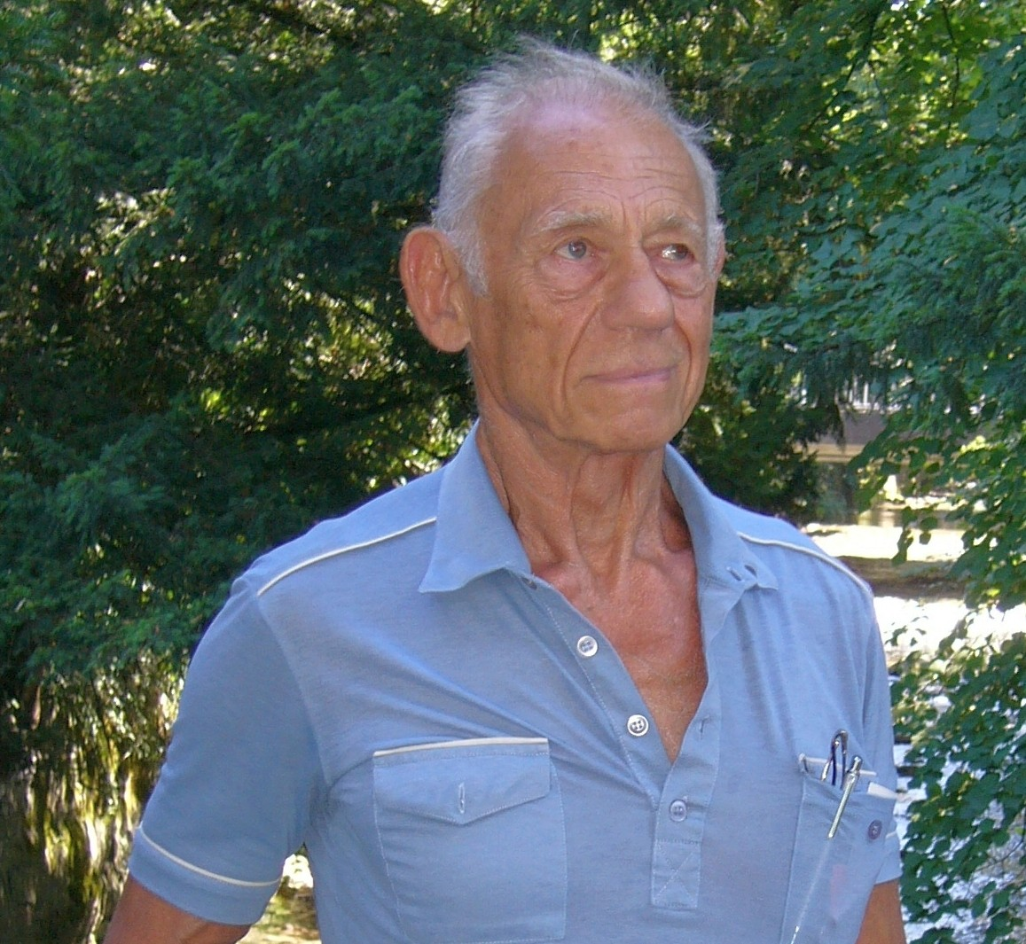
Ludwig Lowenstein, UK
I have been a member of the International Council of Psychologist since 1977 and have enjoyed and benefited in every way from this contact with friends that I have made over the years. I have been an ICP Director-at-Large on two occasions and have also been an Area Chair. However, I do believe sincerely in people and the power of people and in sharing knowledge throughout the world which will improve the situation of people. Some of our members come from developing countries where psychology is still in its infancy and others come from a highly developed country where psychology is well established. We are all restricted by budgets and political restraints but I feel that we can all help one another to develop our ideas and to establish good will across the world. I believe an organization such as ICP can do much to help developing countries and also to help to foster better relationships between people whatever their race, religion or beliefs.
Needless to say my long membership with ICP should indicate that my heart is very much with the organization and the wonderful membership from whom I have made many true and enduring friends over the years. If elected I would like to do the following:
1. To obtain information from the membership their opinion as to where the direction should be for ICP to go in the future and how this can be achieved.
2. To seek to truly internationalize ICP by contacting countries from which we have in recent times had no members and who would enrich our membership and make the organization truly international. I would therefore contact the national organization of all those countries from which we have had members in the past but have not had members recently.
I have lived a very varied life and have travelled widely especially in my youth meeting many different people and cultures. I was born in Germany and my family left there before the Second World War to live in New York City. I attended Stuyvesant High School and following this joined the American Army as a Paratrooper. On my return to civilian life I was a student at New York University taking a pre-med and then eventually a psychology course. After some trekking around the world I eventually ended up in Australia where I achieved my first degree at the University of West Australia. From there I travelled to the UK and immediately enrolled for further studies at London University and obtained a Masters Degree. I started teaching and then went on to Clinical Training in Psychology at the Institute of Psychiatry, The Maudsley Hospital, and finally took my PhD at London University. During my career I have lectured at a number of Universities, mostly as a visiting lecturer, and eventually became the Chief Psychologist for the County of Hampshire. I later received a Visiting Professorship at the University of Khartoum in the Sudan. When I returned to the UK I set up a Therapeutic Community and School with my wife Kathleen which we ran for 20 years. I have written a large number of articles on many varied subjects and some 450 of these have been published. I have dealt with many different problems in my long life and career.


Sherri McCarthy, Arizona, USA
Professor of Educational Psychology, Counselling and Human Relations at Northern Arizona University-Yuma, I have been active in ICP for the past decade: Co-organized the 2005 conference in Foz do Iguacu, Brazil, served on the Board of Directors from 2004-2008, and served as the Membership Chair from 2002-2008; Bylaws Rewrite Committee from 2006-2007, and the Bylaws review Committee in 2008; Forensic Interest Group since 1999, and worked on several books and research projects with former President Edith Grotberg, as well as with other ICP members. I have lived in several countries and has been a visiting professor at Universidade Federal do Rio Grande do Sul in Porto Alegre, Brazil; Vologda State Pedagogical University, Vologda, Russia; University of Bologna, Italy, and University Malaya, Kuala Lumpur, Malaysia; Co-authored the chapter on Brazil for the latest Handbook on International Psychology and has presented research at over 150 national and international conferences and published many articles, chapters and books. Recent books include A Death in the Family: A Guide for Coping With Grief; Dealing With Special Needs Classmates; Teen Violence and its Prevention: A Guide for Parents and Professionals; International Practices in the Teaching of Psychology; Teaching Psychology Around the World, Vol. 1; Building Asian Families and Communities in the 21st Century and Teaching Psychology Around the World, Vol. 2. My current research interests are in peace psychology, adolescent psychology, international psychology and developing critical thinking skills. I am also active in the Asian Psychological Association, currently serves on the Board of Directors; an APA Fellow, active in Division 2, Teaching (liaison to the Council on International Relations in Psychology) and 52, International Psychology (served as Membership Chair from 2002-2004); ICOPE, co-organizing international teaching conferences in Russia, Brazil, Australia and South Africa since 2000.

Goal Statement
My vision for ICP, if elected President, includes the following goals:
- Maintain the warm, friendly, supportive environment which has characterized this organization since the beginning by reactivating the “host” network that allows members to stay at each other’s homes when visiting other countries, and improving personal connections both through dialogue on the webpage and at conferences.
- Continue the recent, positive work of our six previous presidents to re-establish a viable secretariat, solve membership tracking problems, develop long-range planning and refine the bylaws to allow smooth functioning of ICP.
- Build collaborative relationships with other organizations which promote International Psychology and positive international relations.
- Utilize the skills of our members and influence of our organization to promote Human Rights and provide disaster relief.
- Listen to the needs of our members from all countries and help support the dreams and goals of each of them.
If elected, I plan to clear my calendar a bit and devote my attention to ICP throughout 2010. I will be on sabbatical from my university that year, and in Australia during much of that time, helping to organize conferences for ICOPE and the Asian Psychological Association—and, of course, for ICP, too as needed! It was an honour to be nominated for this office, and would be an honour to lead ICP and carry on the positive efforts and dreams of all my mentors who served before me.

2. Candidate for Treasurer
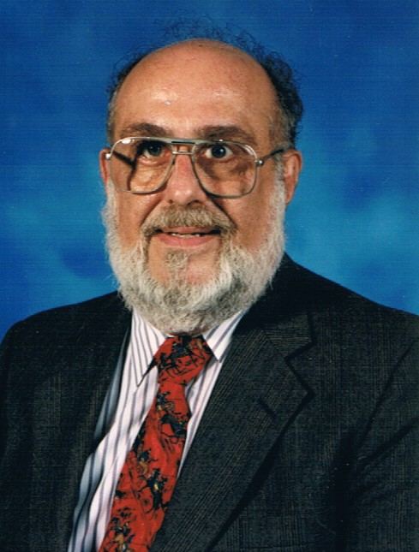

Gerald L. Gamache (USA)
I am honoured to put forth my name as Treasurer of the ICP. I feel confident that I can bring fiscal responsibility and integrity to funds entrusted to me. As a Board member I will be open to new ideas and use my skills in facilitating group discussion. I look forward to meeting each of you and serving as Treasurer for the coming year. Below is a summary of my career and achievements.
Gerald (Jerry) Gamache graduated with a Ph.D. in Industrial-Organizational Psychology from Old Dominion University after having received his Bachelors and Masters from the University of North Florida. In addition, he has received two honorary doctorates; one from Ukraine in mathematics and one in medicine from Chile. He taught college for 30 years and was on the adjunct faculties of the University of Southern California; University of Denver; Old Dominion University; and full-time faculty at Flagler College. He has written seven books in three languages, 28 research articles, and presented papers at numerous conventions. He is an internationally acclaimed scientist, researcher, and author. Some of his awards include 2005 Distinguished Alumni of Old Dominion University; among the Top 2000 Scientists of the 20th Century; and the 2006 Nelson Butters Award for Research Contributions to Neuropsychology and participation in the 2009 Oxford Round Table covering Ethics: The Convulsion of Contemporary Values held at Lincoln College, Oxford.

3. Candidates for Board Directors at Large
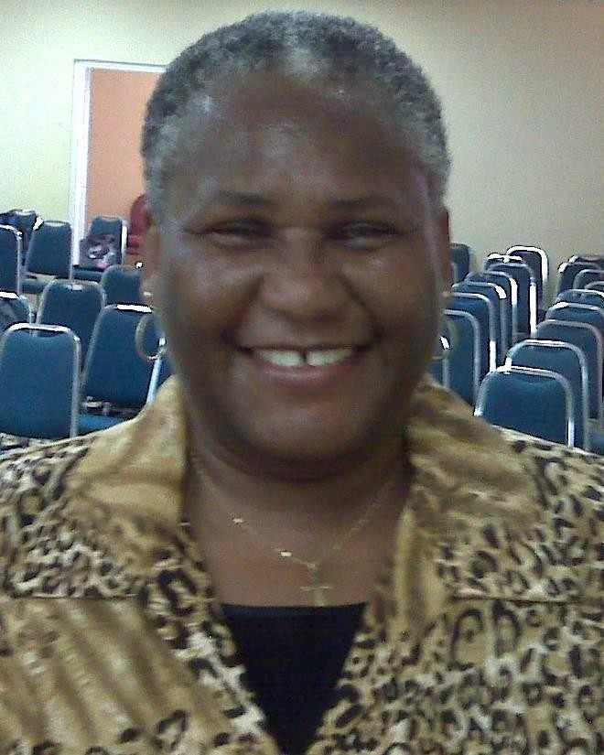

Justina E. Aire (Grenada)

Dr. Justina E. Aire (Ph.D., University of Ibadan), is a Nigerian-South African. Her special areas of research interest are Counselling, Social and Health Psychology, with a bias for gender issues in reproductive health counselling, promotion and fostering of HIV/AIDS preventive behaviour and Sexual Behaviour Modification, among adolescents, young adults and married people. The combination of counselling and therapy, based on the Logotherapy principles of meaning-centred way of living helps her in no small measure to achieve success. Dr. Aire is currently an Associate Professor in the Department of Liberal Studies of the School of Arts and Sciences, St. George’s University, Grenada. As an adjunct Professor with the School of Veterinary Medicine, she is the Team Psychologist of the Professionalism Attributes Workshop. She has contributed articles in scholarly journals and books. She has been active in recent years attending and presenting papers at ICP conferences. She is married, with children and grandchildren who keep her grounded.

Cheng-Chien Chen (Taiwan)
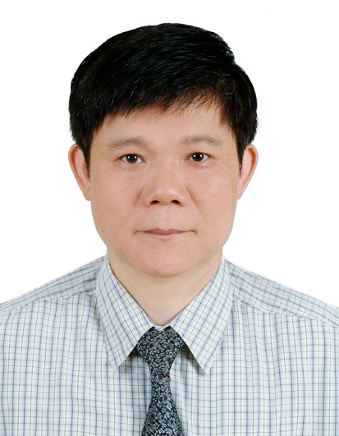

CHENG-CHIEN CHEN (Ph.D. National Chang Hwa University, Taipei) comes from Taiwan and is Professor of Educational Psychology at the National Chiayi University in Chiayi, Taiwan. He has been an active ICP member since 1996 attending and presenting his research papers and workshops on calligraphy therapy. He is also particularly interested in what children with ADHD understand in educational situational settings and how teachers might be able to use that information when they communicate with parents of ADHD. He had published several textbooks such as Calligraphy Therapy (in Chinese and Korean), Assessing Children with Special Needs and Activity Rating Scales for elementary children and Activity Rating Scales for preschool children, Leadership Aptitude test. His other published books include: Behavior Modification Assessment and Evaluation for Exceptional Children, and Assessing Strategies for Children with Special Needs .His teaching interests: cognitive psychology, issues on special education, calligraphy therapy. He hopes to be of service to ICP as A Director at Large and welcomes ICP members to his university personally and as a future location for ICP conferences.

Joan DiGiovanni (USA)

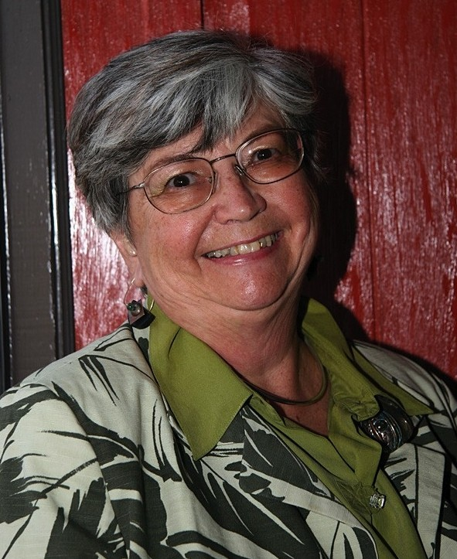

My first ICP conference was in San Francisco 1983 followed by New York City 1987. I feel that I grew up psychologically in ICP as I could share my research in many presentations of different artists at ICP meetings (Winchester, England 2001, Graz, Austria 1997, Lisbon, Portugal 1994, San Francisco, CA 1991). I have served on the Denmark-Grunvald Award Committee and participated on the Gender Research Interest Group over many years. I also was Area Chair for MA & AZ. I donated to the Research in Gender Studies Fund, due to the inspiration of Florence Denmark, Joan Chrisler, and Ann O’Roark. In 1999, I was awarded Professor Emerita from Western New England College, Springfield, MA and entered the painting program at the University of Arizona, Tucson, with additional painting studies at the International School of the Arts, Todi, Italy (2000), the Vermont Study Center, Johnson, VT (2002), and Chouinard Art Foundation, S. Pasadena, CA (2004). For the past two decades I presented Psychobiographies of Women Artists internationally and domestically and co-authored with Dr. R. Lee, AIMED (American Institute of Medical Education) Psychological study of Art & Artists. My understanding of artists was further enriched by my privileged position of hearing artists’ life stories in psychotherapy with me. ICP and its members have encouraged my own growth. I would like to provide similar opportunities with for others.

Hing Keung Ma (Hong Kong)
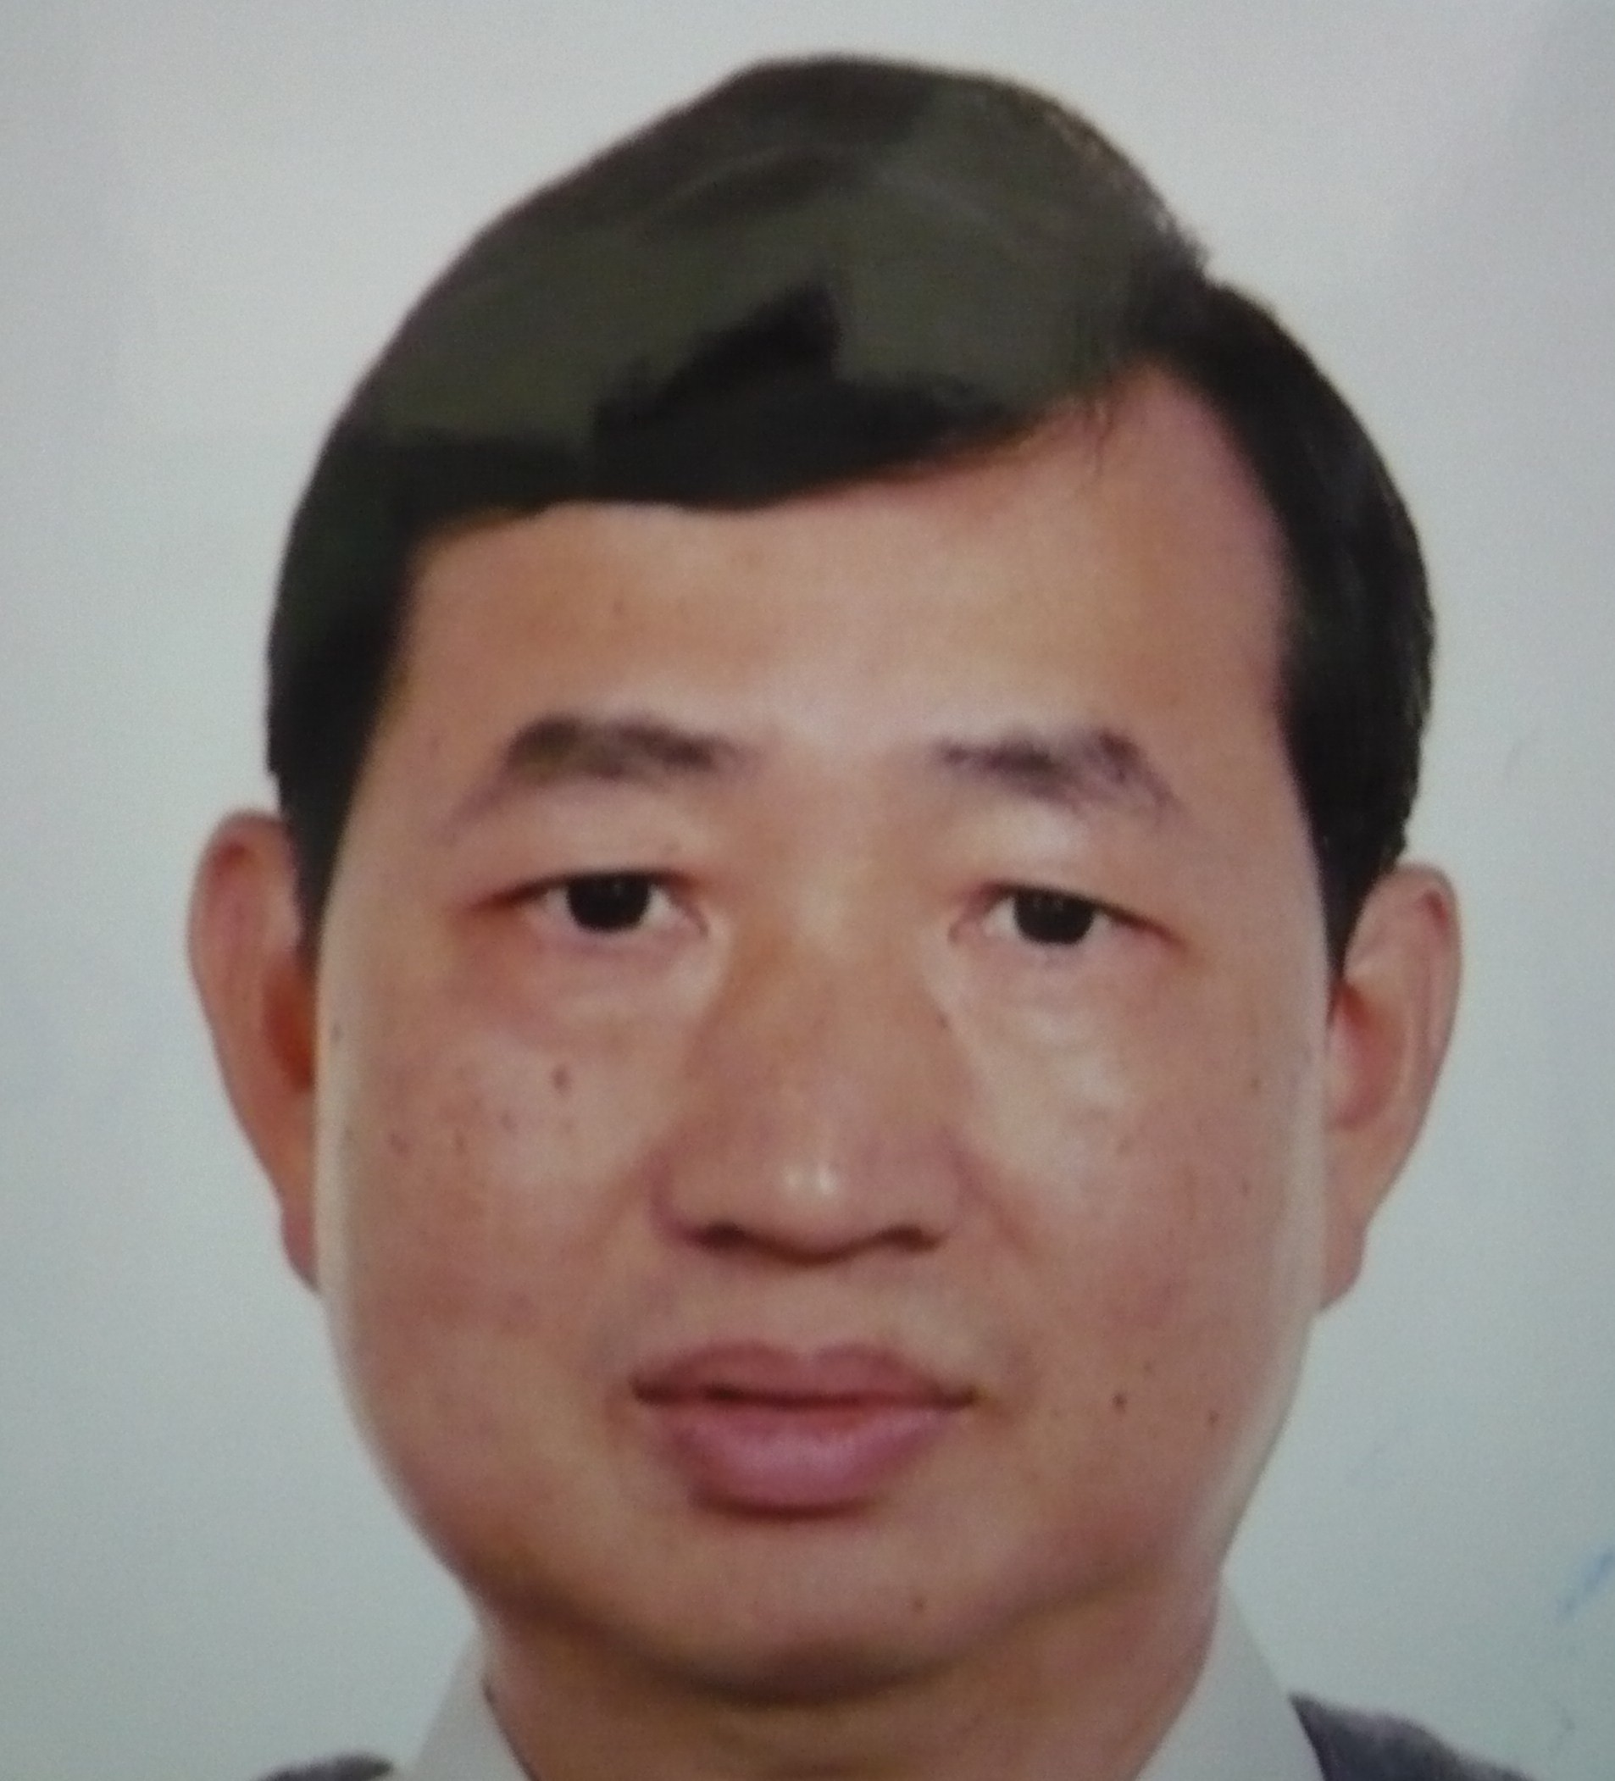

Hing Keung Ma (Ph.D., University of London) has been a member of the ICP since 1987. He is Professor in the Department of Education Studies, Hong Kong Baptist University since 1997. He has a Ph.D. in child development from the University of London. He is Consulting Editor of International Journal of Psychology and Indigenous Psychological Research in Chinese Societies, and former Senior Editor of Journal of Psychology in Chinese Societies. He is also a Fellow of the Hong Kong Psychological Society. His major research interests and extensive publications include moral development, prosocial and antisocial behavior, moral education, and whole-person education. He wishes to do something for the welfare of children in China and other less developed countries in his specialty.

Robert Morgan (USA)
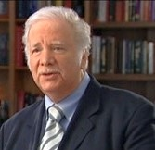

Robert Morgan (Ph.D.) is Professor and Chair of the Clinical Psychology Program, Michigan State University. He is a Fellow and Life Member of the American Psychological Association. A member of the International Council of Psychologists, he served from 1982 to 2006 on the Executive Committee and Board of the International Association of Applied Psychologists as a Founding President of the Division of Applied Gerontology, receiving in 2001 the American Psychological Association’s Distinguished International Psychologist Award. Professional consultation over the last four decades has included government agencies from Peace Corps to the U.S. Office of Education, community organizational change groups such as Dr. Martin Luther King Jr.'s SCLC, and the Native American Health Centre in Oakland. His current practice includes services to individuals and practitioners, as well as organizational/educational consultation including clinical supervision and training, accreditation, doctoral dissertation supervision (80 to date), and program development. More than 70 articles, chapters, books, and tests include community clinical/cultural psychology, health psychology, applied gerontology and aging, general-experimental psychology, psychology of time, forensic psychology, and the prevention of iatrogenic practice.

Maria Rosa Mazzolini (Italy)
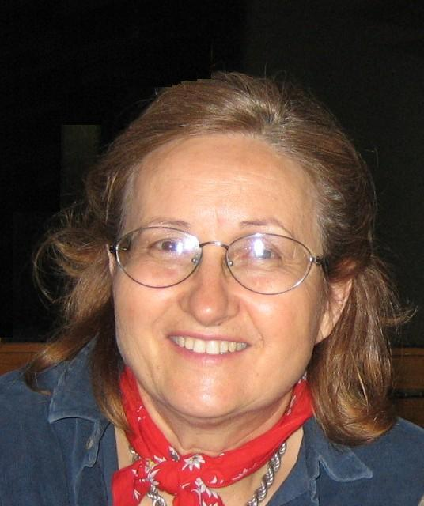

Maria Rosa Mazzolini is a clinical psychologist. She graduated at the University of Padova where she specialised in group therapy. She has always supported mutual co-operation and understanding among people from different countries and cultural backgrounds, in all fields of life. As ICP Area Chair (Italy) she has participated with growing involvement to the most recent ICP conventions and shares ICP’s values and aim to strengthen bonds and communication channels among psychologists, and to develop an interest in ICP from students and young graduates.
At present she works for the University of Padova, doing research mainly in the field of family and gender issues. She has her own private practice and is a trainer for the Institute of Psychosynthesis based in Florence, for which she holds seminars and groups in various Italian cities. She has been a school counselor for many years and has promoted various exchange projects with countries in Europe, America and Australia, bringing in contact foreign and Italian students. Grown in an international milieu, she is fluent in English, German and French, and is conversational in Spanish.

Imelda Villar (Philippines)


Imelda Villar (Ph.D., Clinical Psychology - University of Santo Tomas) has been actively involved in Counselling and Psychology Organizations in the Philippines and in Asia since the 1970's.She is the current President of the Association of Psychological and Educational Counselors of Asia-Pacific (APECA). She is the current President of the Philippine Guidance and Counselling Association (PGCA), and leadership positions in the Psychological Association of the Philippines; and the Philippine Association for Counselor Education, Research, and Supervision. Aside from being a professorial lecturer at the De La Salle University and St. Scholastica's College, Dr. Villar conducts training programs on various areas of counselling and psychology in different parts of the Philippines and Asia. She has written nine books in the field. She is very much involved in organizing and implementing Conventions, Workshops and Learning Sessions.
Dr. Villar has been a member of the International Council of Psychologists since 1977. She was actively involved in committees during the times that ICP held its activities in the Philippines. She believes that the efforts of many organizations of psychologists all over the world could be animated by associating with International Council of Psychologists.

Rukhsana Kausar (Pakistan)

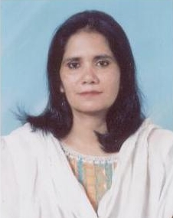
Rukhsana Kausar,(Ph.D., Surrey University, UK) is Professor and the Chairperson, Department of Psychology and Applied Psychology, University of the Punjab, in Lahore, Pakistan. Her main research interests: are in psychological implications of neurological disorders, Health Psychology and gender issues. She has published thirty four research papers in journals of national and international reputation and served as Editor of several prestigious journals in Pakistan. She has been a member of ICP since 2003 and has attended and presented papers in ICP conferences. She welcomes collaborative research and involvement from ICP members to her university.


Introducing the New Editors
Sonia Dhaliwal, MA, Managing Editor
Sonia Dhaliwal holds a Masters degree in Counselling Psychology with an emphasis in Organizational Behavior from Pacific University. She is currently working towards her doctorate in Clinical Psychology, with a focus on Organizational Consulting/Behavior, from the same university. Sonia has a variety of research interests stemming from Organizational Behavior/Consulting to issues pertinent to Multiculturalism and Diversity. She has spent time in South-East Asia, West Africa, Hawaii and currently resides in Portland, Oregon. Sonia has presented research on multicultural issues in a variety of professional conferences some of which include the American Psychological Association (APA), Association for Behavioral and Cognitive Therapies (ABCT) and she will be presenting at the upcoming Asia Pacific Sociological Conference (APSA) in Bali, Indonesia.

Elizabeth Stotler-Turner, MS, Co-Editor
Elizabeth Stotler-Turner holds a Masters degree in Clinical Psychology from Pacific University. She is currently working towards her doctorate in Clinical Psychology, with a focus on Forensic Psychology, from the same university. Elizabeth has worked with juveniles and adults convicted of sexual crimes for over four years in a variety of settings, including outpatient treatment, corrections, community corrections, and research. She also has worked with LGBTQ persons and people of various ethnic identifications and nationalities who are involved in the legal system. Further, Elizabeth has presented at both international and local conferences on topics relating to sexual offenders and pertinent diversity topics.

ICP Membership Application – 2009

Membership Chair: Julia Rose, PhD: Julia.Rose@hmps.gsi.gov.uk

PLEASE WRITE “YES” IN FRONT OF THE CLASS OF MEMBERSHIP FOR WHICH YOU ARE APPLYING

MEMBERSHIP STATUS IS REVIEWED BY THE ICP MEMBERSHIP COMMITTEE AND BOARD CONFIRMED

______ A MEMBER is a psychologist who (a) holds or is eligible to hold membership in a national psychological association affiliated with the International Union of Psychological Science (IUPsyS), or (b) meets comparable requirements in a particular country, as determined by the application review agent, and (c) has been actively engaged for a period of not less than two years prior to application for membership in professional work or study that is primarily psychological in nature.

______An ASSOCIATE is an individual who at the time of application does not meet requirements for Member. The applicant meets the requirements for Member except (a) for the two years of qualifying experience; or (b) in those countries in which the national psychological association affiliated with the International Union of Psychological Science recognizes a higher and lower level of qualification for different classes of its members, an Associate is one who qualifies at the lower level, and is actively engaged in professional work, study, or research that is primarily psychological in nature; or (c) are applicants who meet comparable requirements in a particular country, as determined by the Membership Applicant Processing Coordinator and approved by the Board.

______A PROFESSIONAL AFFILIATE is a person who is professionally active in a profession allied to psychology who is interested in helping to advance the purposes of ICP.

______ A STUDENT AFFILIATE is a graduate student or full-time undergraduate student actively working toward a degree or certificate in psychology or in an area of study involving major emphasis on psychological aspects of a related field of study.

PREFERRED TITLE: ___ Dr ___Prof ___Mr ___Mrs ___Ms ___
Languages spoken________________

FULL NAME (Print)__________________________________________________

PREFERRED MAILING ADDRESS (Print)
Street number & name ___________________________________________________
City__________________State___________Zip/Mail Code___________Country___

TELE Home__________________TELE Work_________________ FAX___________
CELL PHONE___________
E-MAIL_________________________________
HIGHEST APPROPRIATE DEGREE OR CERTIFICATE (All needed = Degree, Date, Major Subject, Institution, Location)
______________________________________________________________________
Student Afﬁliate applicant—you must provide (1) the name and address of your university, (2) name and address of your major professor, (3) your anticipated degree or certiﬁ cate, and (4) your anticipated date ofgraduation. ______________________________________________________________________
ENDORSERS: (one or two—see instructions below): Names, addresses, and EMAIL addresses
______________________________________________________________________

1.If you are a member of a national psychological association affiliated with the International Union of Psychological Science (IUPsyS), and are endorsed by at least one current ICP Board Member and/or Area Chair, you do not need to provide any other endorsement than the typed full name of that endorser or endorsers on the application.

2. Other applicants: Please ask two professional persons to sign as endorsers on the other side of this application, or have them send a letter of endorsement directly to the ICP Secretariat (address at the top of this page). These endorsers should be familiar with your training and/or experience in psychology, and should either be members of ICP or be
recognized professional persons who can be identified by the Membership Application Processing Committee.

Your application is not complete and will not be processed until these required endorsements are received. If endorsers are not available, please submit a complete curriculum vitae or resume with your application.

EXPERIENCE (last 2 positions or last 10 years)-(NEED Dates, Titles, Institutions or Companies, and Locations)_____________________________________________________________________________________________________________________________________
MEMBERSHIP(S) IN PROFESSIONAL SOCIETIES (NEED Society Name, Admission Date, and Membership Class)

If your interest in ICP was encouraged by someone other than an endorser, give the name(s):________________________________________________________________

Your signature: _________________ Name________________________Date________

PAYMENT: The ICP Membership year is from January 1 – December 31.

Country of residence determines dues category. Please write “yes” in front of one category.

______CATEGORY “A” COUNTRIES OR AREAS: $85 (U.S. DOLLARS)
(Australia, Austria, Bahrain, Belgium, Brunei, Canada, Denmark, Finland, France, Germany, Great Britain, Greece, Hong Kong, Iceland, Ireland, Israel, Italy, Japan, Kuwait, Luxembourg, Netherlands, New Zealand, Norway, Portugal, Qatar, Saudi Arabia, Singapore, Spain, Sweden, Switzerland, Taiwan, United Arab Emirates, USA)

_____ CATEGORY “B” COUNTRIES: $45 (U.S. DOLLARS)
(Antigua & Barbuda, Argentina, Bahamas, Barbados, Brazil, China, Croatia, Cyprus, Czech Republic, Iran, Korea, Malaysia, Malta, Mexico, Oman, Poland, Seychelles, Slovakia, Slovenia, South Africa, Suriname, Turkey, Venezuela,Yemen)

____CATEGORY “C” COUNTRIES: $25 (U.S. DOLLARS) (All other countries)
____STUDENT AFFILIATE: ___CategoryA: $25US ___CategoryB: $22US ___CategoryC: $17US
____IAAP Members applying for ICP alliance status membership are to send $25 to ICP Secretariat

DUES AMOUNT $________

Submit this completed membership application form to Membership Chair Julia Rose.

